



Index

1. Software description 1

2. Opening the software 2

3. Items to keep in mind 5

4. Software functionalities 5

4.1. Input and Output options 5

4.1.1. Open a file 5

4.1.2. Erase all marks button 7

4.1.3. Save files 8

4.1.4. Exit the sonoUno 13

4.2. Reproduction options 14

4.2.1. Abscissas position 14

4.2.2. Tempo selection 15

4.2.3. Play and Pause button 15

4.2.4. Stop button 16

4.2.5. Mark point button 17

4.2.6. Delete last mark button 18

4.2.7. Data parameters button 18

4.3. Data management options 21

4.3.1. Cuts on the abscissa’s axis 21

4.3.2. Mathematical functions 23

4.4. Configuration options 28

4.4.1. Sound configurations 29

4.4.2. Plot configurations 30

4.5. Help options 35

# 1. Software description

SonoUno is a sonification software for astronomical data presented on a table (txt or csv files). The software is being developed based on the study of other software (Sonification Sandbox, MathTrax and xSonify) and standards of accessibility like the ISO 9241-171:2008 (Guidance on software accessibility). In order to develop an accessible graphical user interface, we perform a theoretical framework based on bibliography of user cases, focused on blind and visual impairment people and we conduct a focus group session with visual impairment people and sight people.

The develop language is Python and we use modular design, in order to do collaborative work. The sonoUno now is multiplatform, tested on windows 10, Ubuntu (16.04 and 18.04), CentOS 7 and Mac (Mojave and Catalina); the development team work continuously to maintain this benefit. The principal goal of the SonoUno is to allow the user to open data files (txt or csv extension), show the plot and sonify the data. At the moment, the sonification is perform by variation of pitch and volume. The sonification settings allow to change the volume, the min and max frequency and the timbre. Also, the sound setting allow to modify the envelope of the sound.

Additionally, SonoUno allow to select a specific range of data on the ‘x’ axis, mark and save point of interest in the data, apply predefined mathematical functions (for example, logarithm and square) and manipulate the data arrays with an Octave interface. In the section settings, the user can configure the plot and some features of the sound. Also, the software allows the user to save the plot, the sound, a text file with the points marked on the data and a csv file with the plotted data.

Finally, the software has a web page with all the information presented here, the manuals, instructive, the link to a web version and a gallery (<https://www.sonouno.org.ar/>).

# 2. Opening the software

Once the software is installed, to open it you have to type on terminal ‘python3 sonoUno’ or ‘python sonoUno’, depending how you call python 3 on your operative system. That action opens the sonoUno main window (Image 1). If an error is shown on terminal during the session is recommended to do a screenshot or copy the message and communicate this to the development team.

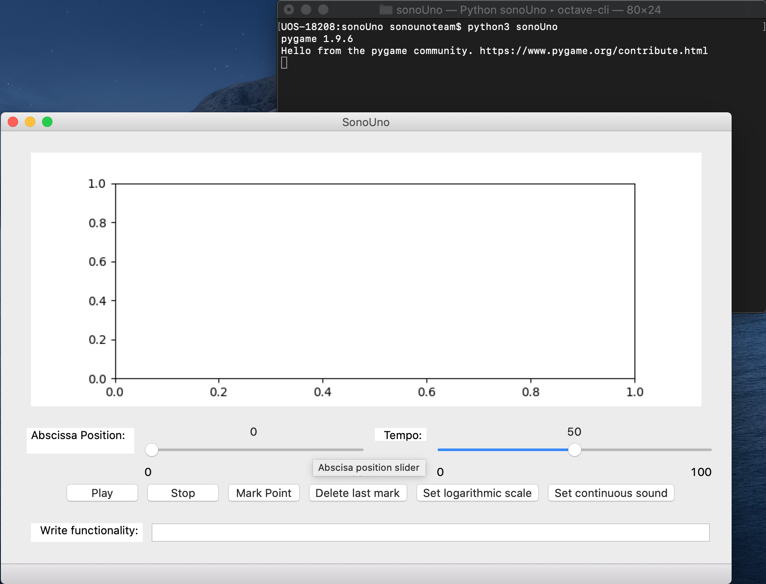

*Image 1 – The image shows the terminal and sonoUno main window.*

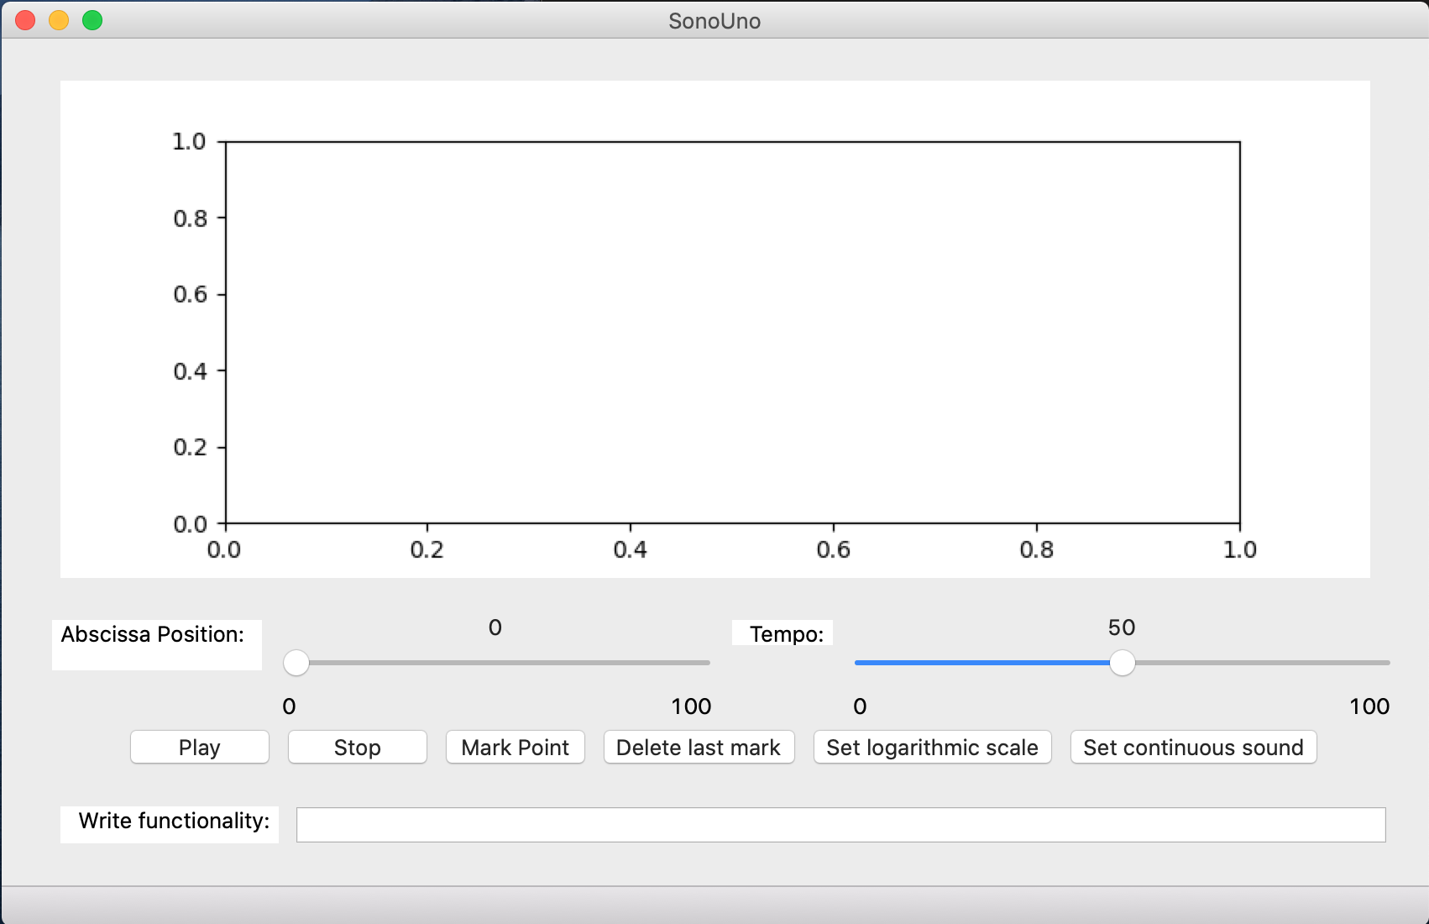

*Image 2 - SonoUno initial window.*

The initial window of the software only shows the plot, the reproduction options of the data and the functionality text entry (Image 2), the other functionalities are hide and will be shown in the next chapters. This design was based on a user cases study and confirmed by a focus group analysis.

In order to probe the SonoUno, you have to import a data file. If you don’t have one, the source code folder provides a folder named “sample_data” with simple functions on the installation or source directory. One aspect to take in mind is that sonoUno works with numerical data in table format, that’s means that sonoUno try to store in a DataFrame variable the columns with numbers so: if it could detected numbers in two or more different columns, it will be stored, and it will be plotted with matplotlib (first column as x-axis; second column as y-axis; it could be changed later), the x-axis was consider for the time variation in the sonification; if the data are text, for example, and the software couldn't detect any number, through an error explaining the problem found.

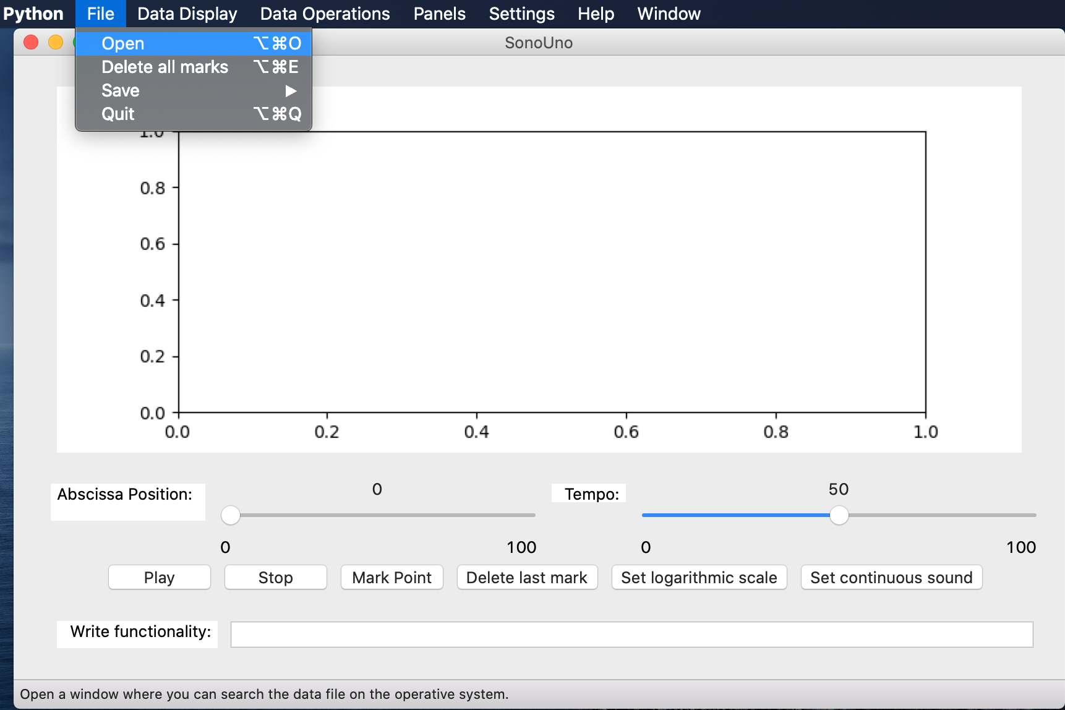

*Image 3 - Open a file: choose the item Open on the menu File.*

The first step to open a data file, is to select the item Open on the menu File (Image 3). This action shows a new window of the file system of the computer, where you can choose the data file. Once you have the data file selected, press the button “Open” (Image 4).

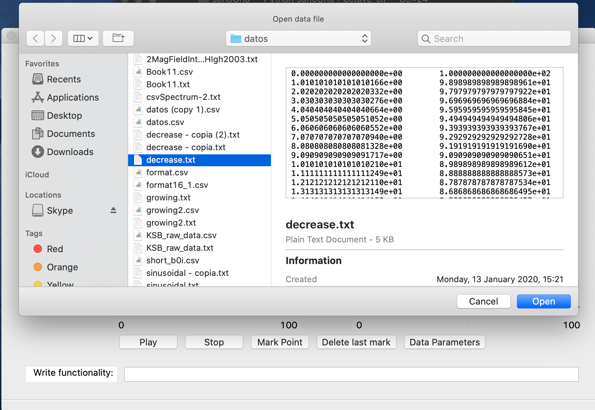

*Image 4 - New window of the file system of the computer.*

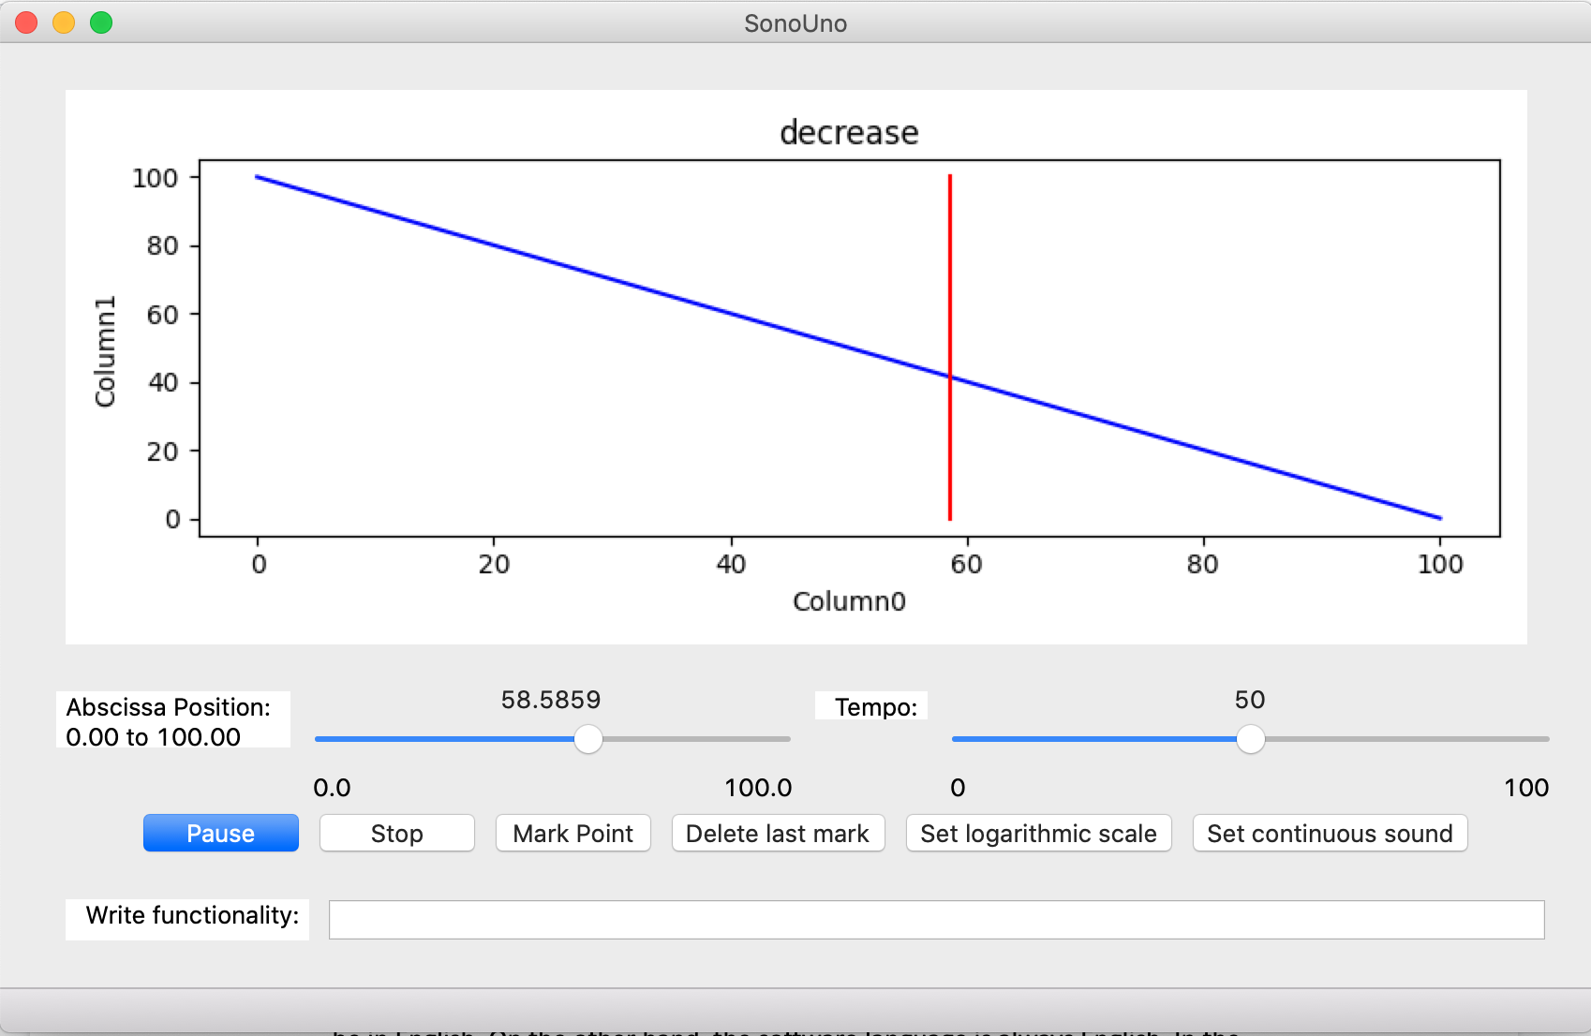

*Image 5 - Reproduction of the data file after press the button Play.*

After open the data file, the SonoUno show the plot and is ready to reproduce the sound. In order to listen it, you have to press the button Play (Image 5). If the software installation is correct: the name button changes to Pause, you can listen a pitch variation and see a red vertical bar moving through the data, this bar indicate the position of the data that is been sonifyed.

If the software doesn’t produce sound, check the speakers or headphones on your computer. If the problems continue or you have another problem, inform this to the developer team ([sonounoteam@gmail.com](mailto:sonounoteam@gmail.com); or GitHub page: <https://github.com/sonoUnoTeam/sonoUno-desktop>).

# 3. Items to keep in mind

* The extra windows of the software are generated with the native language of the operative system, for example, if your system is in English the pop-up windows will be in English. On the other hand, the software language is always English. In the future the team expect to unify the languages.
* In the files to import the first column must have continuous values, it is used as a coordinate dependent axis.
* All the images are representative, the real image can change a little depending on the operative system.

# 4. Software functionalities

## 4.1. Input and Output options

### 4.1.1. Open a file

To open a file, one of the options is to press the item Open of the menu File (Image 6). This action shows a pop-up window of the file browser of the computer (Image 7), were you can search and open the data file.

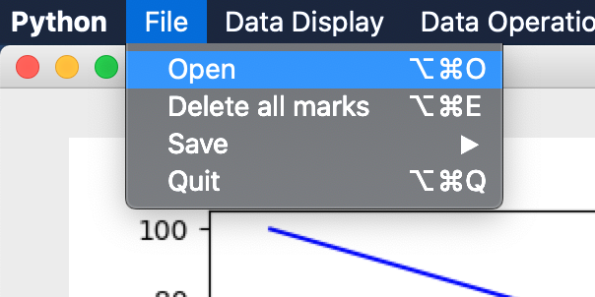

*Image 6 - Show the items on the menu File and the focus of the keyboard is on the Open item.*

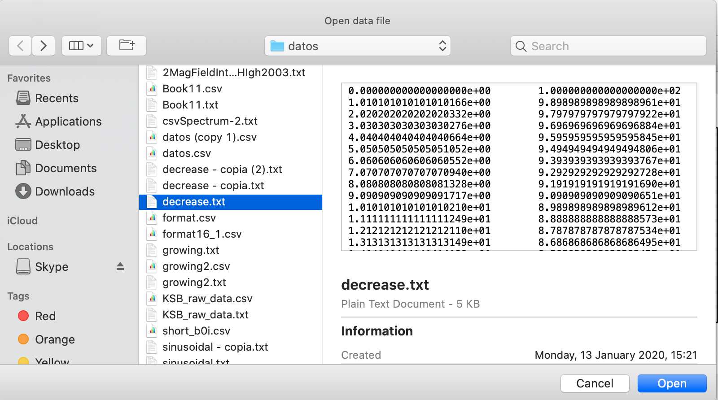

*Image 7 - Pop-up windows of the File browser, shown after press the item or button Open.*

When you have the data file selected, you must press the button Open or the Enter key. Then the sonoUno generate the graph of the data (Image 8) and update the abscissas slide bar. With the button Play you can reproduce the sound of the data.

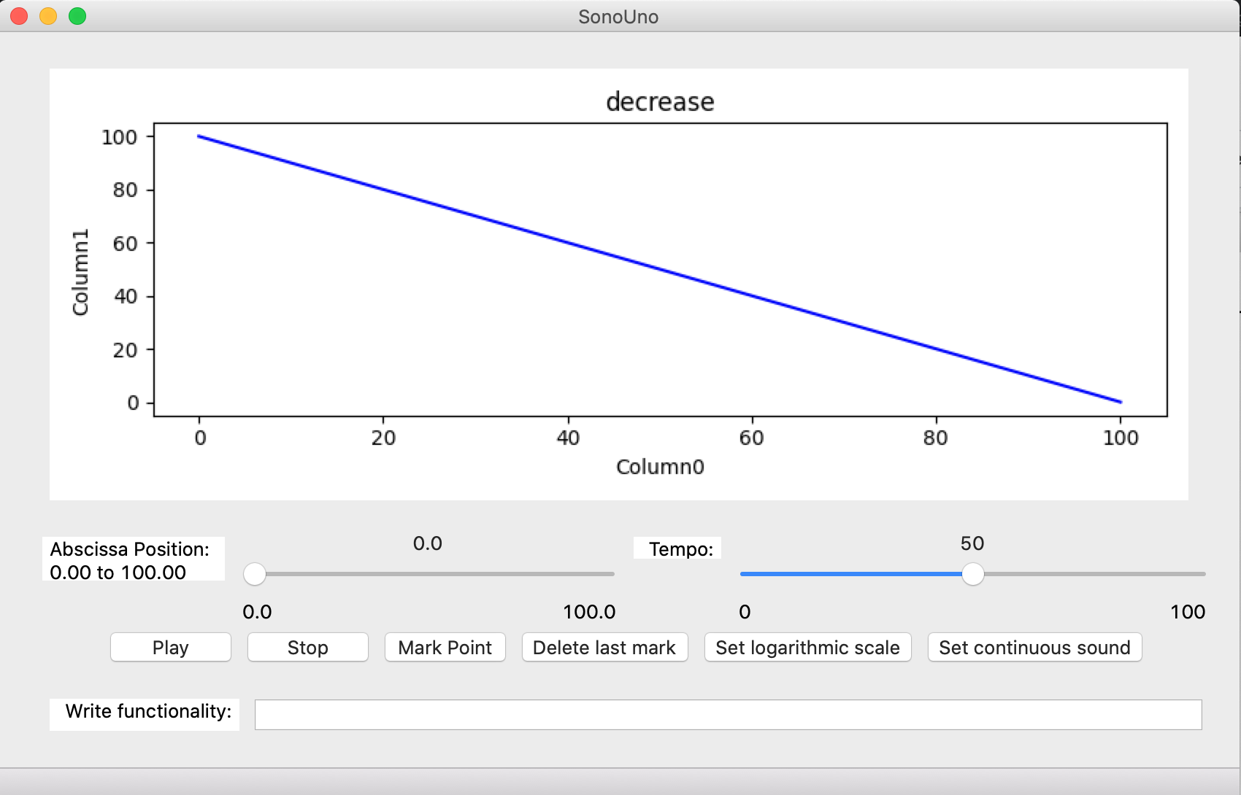

*Image 8 - The sonoUno framework with the graph of the imported data.*

Other ways to open a data file are the shortcut key (‘Ctrl + Alt + O’ or ‘option + command + O’) or show the file panel with the item File of the menu Panels (Image 9). The file panel contains six buttons and is located on the left of the user (Image 10).

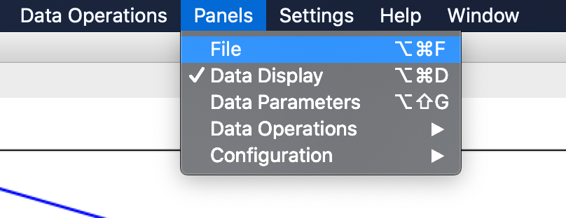

*Image 9 - Show the items of the menu Panels and the focus keyboard is on the File item.*

The first button (Open) show the file browser pop-up windows (Image 7), the next steps are the same of the previous instructions.

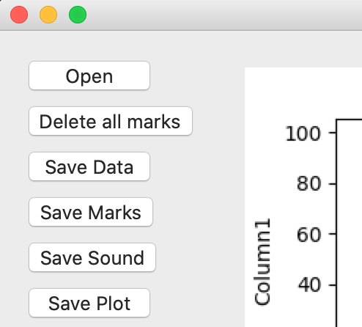

*Image 10 - Show the file panel, where there are six buttons (Open, Delete all marks, Save Data, Save Marks, Save Sound and Save plot) with the keyboard focus on the Open button.*

### 4.1.2. Delete all marks button

Before start with this functionality, we must explain that the sonoUno allow the user to mark points of interest on the data, and store the coordinates on a vector. These marks are shown with a vertical black line on the plot (Image 11).

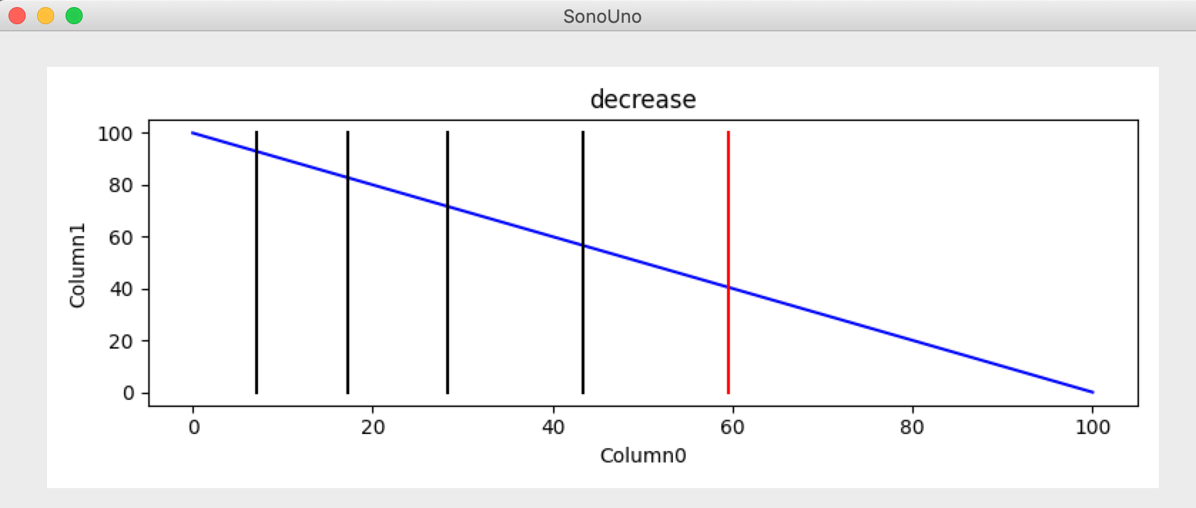

*Image 11 - Display the sonoUno interface with an open data file, in the plot there are one vertical red line (position of the playing coordinate) and several vertical black lines (coordinates of the mark points).*

The functionality of the item Delete all marks, placed on the menu file (Image 12), is to erase all the marks on the data without save anything.

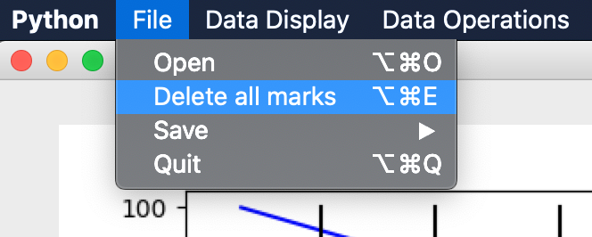

*Image 12 - Show the items of the menu file and the keyboard focus on the item Delete all marks.*

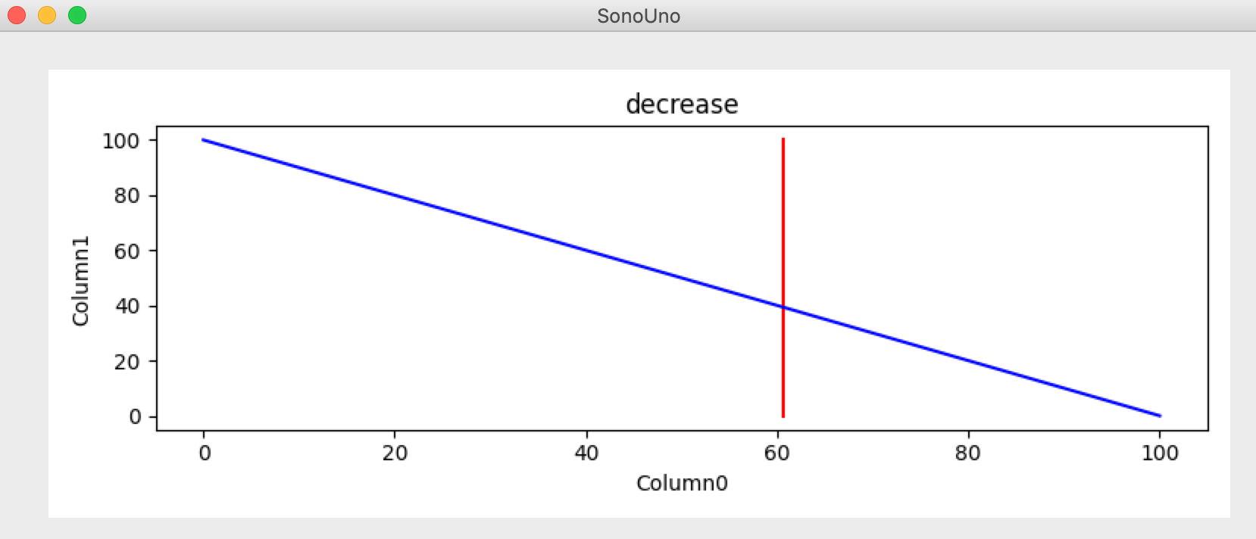

*Image 13 - SonoUno interface with data plotted and the vertical red line. The vertical black lines were erased after use the Delete all marks button.*

Since the marks vector is deleted with that action, the marks on the data plot are deleted too. Now, on the graph there are the data and, if the position is different to initial, also the vertical red line (Image 13).

In addition, other way to delete the marks is to use the button Delete all marks placed on the file panel. To show the file panel you have to select the item File on the menu Panels (Image 9). The panel with the six buttons is on the top-left of the user in the sonoUno framework (Image 10).

### 4.1.3. Save files

There are two ways to save files: one is in the file menu, the save submenu; and the other is with the button placed on the file panel (Image 10), which one have to be shown with the File item in the Panels menu (Image 9). The both methods have the same results.

The software allows to save the data plotted on a csv file, to do that you have to use the ‘Save data’ item on the menu ‘File’, submenu ‘Save’ (Image 14). Other option is the button ‘Save data’ on the file panel (Image 10).

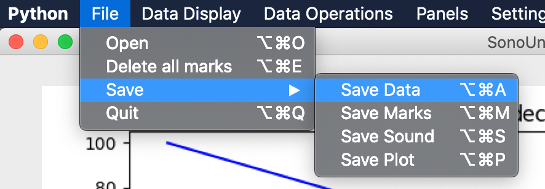

*Image 14 - Show the save submenu selected in the menu file. Inside the save submenu there are four items, the save data item has the focus keyboard.*

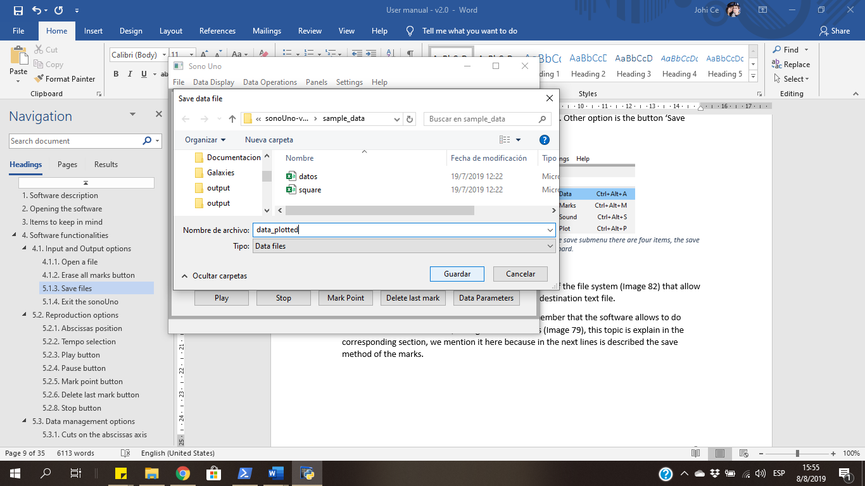

*Image 15 - Pop-up window of the computer file system, where the user can write the name and select the destination folder of the save file.*

The save data option shows a pop-up window of the file system (Image 15) that allow the user to select the directory and the name of the csv file.

Before continue with the save methods, remember that the software allows to do marks of interest on the data, saving the coordinates inside an array (Image 16), this topic is explain in the corresponding section. We mention it here because in the next lines is described the save marks method.

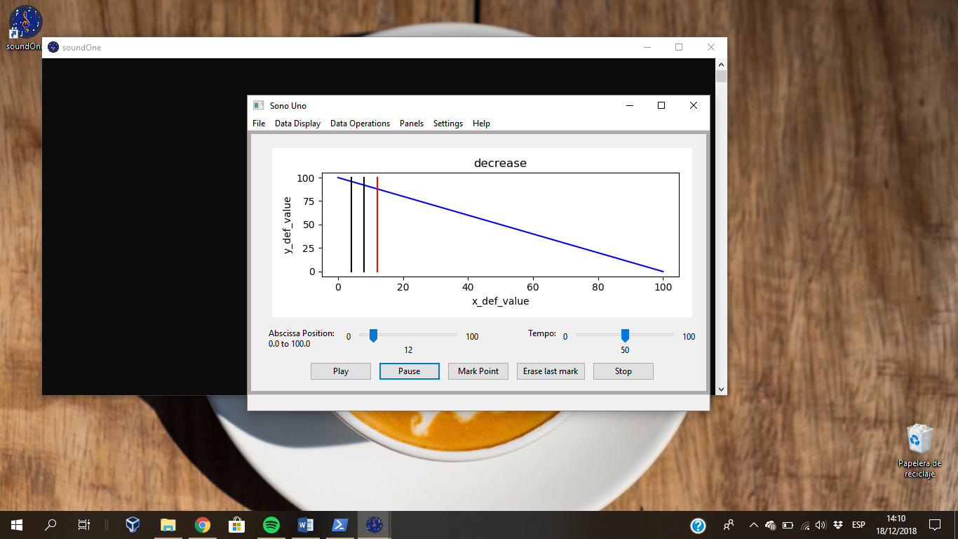

*Image 16 - Shown the sonoUno interface with the vertical red line, indicating the reproduction position, and to marks on the data, which are indicated with two vertical black lines.*

To save the values of the marks performed on the data array the user have to press the save marks item, placed on the save submenu on the file menu (Image 17), or press the save marks button on the file panel on the left of the window (Image 10) (to enable the panel press the file item on the panels menu).

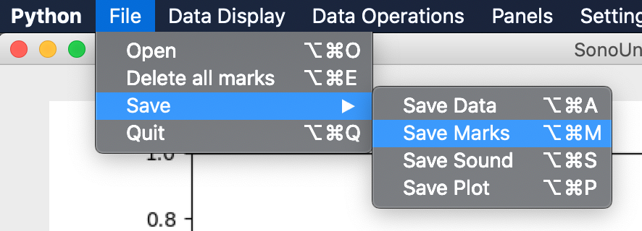

*Image 17 - Show the save submenu selected in the menu file. Inside the save submenu there are three items, the save marks item has the focus keyboard.*

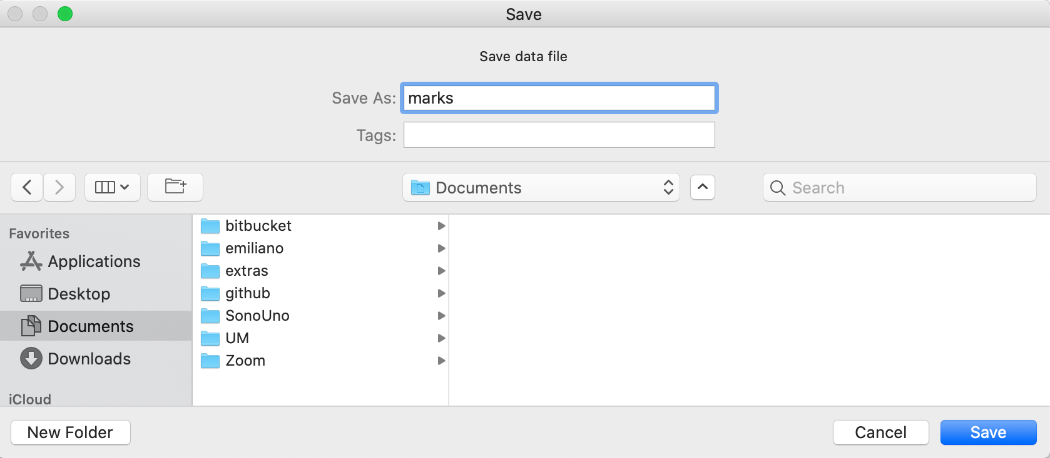

*Image 18 - Pop-up window of the computer file system, where the user can select the destination folder of the save file.*

The save marks option shows a pop-up window of the file system (Image 18) that allow the user to select the directory and the name of the text file. After save them, the marks are deleted from the sonoUno and the plot (Image 19).

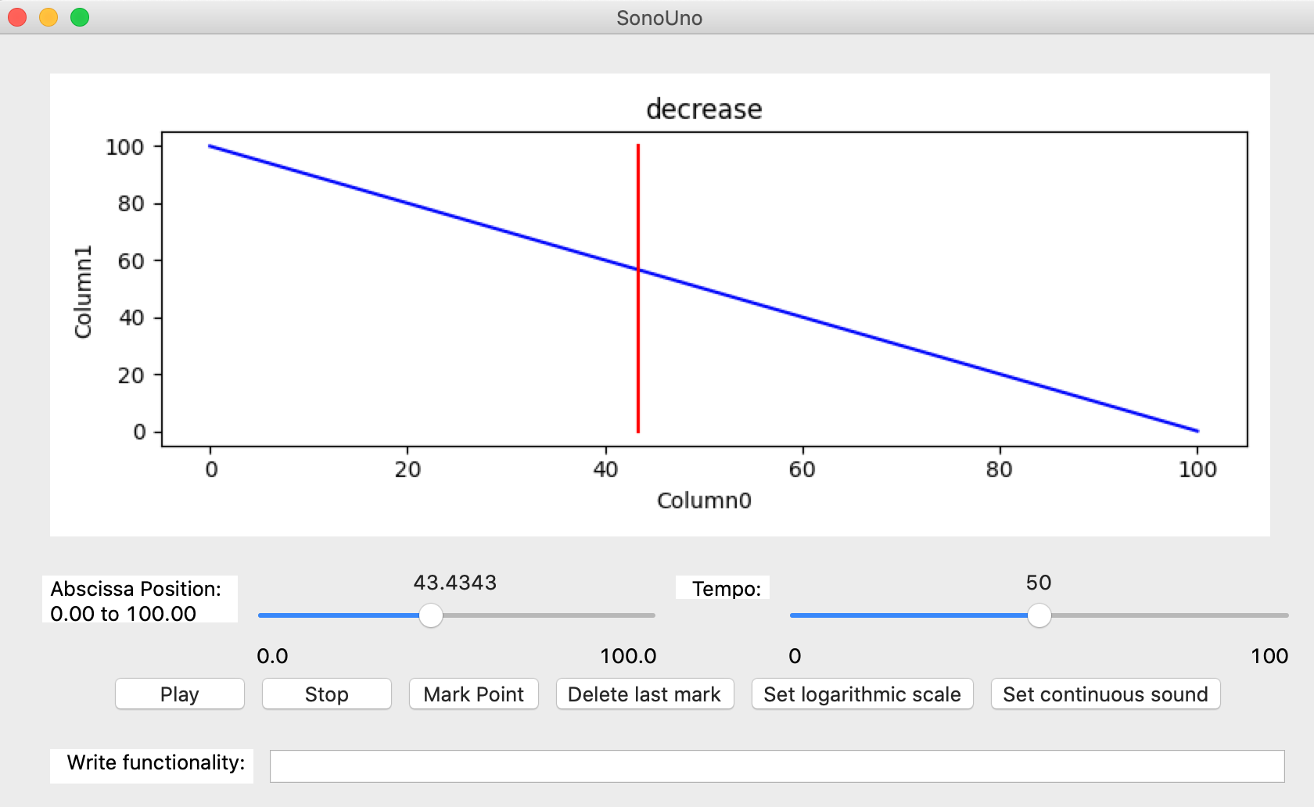

*Image 19 - Show the interface after save the marks, the coordinates data and the vertical black lines were deleted from the software.*

Other save option is the sound of the data. The software will save the sound corresponding to the actual data plot but with some standard sound configuration. In order to save the sound, the user have to press the save sound item on the save submenu of the file menu (Image 20), or the button save sound on the file panel on the left of the window (Image 10) (to enable the panel press the file item on the panels menu).

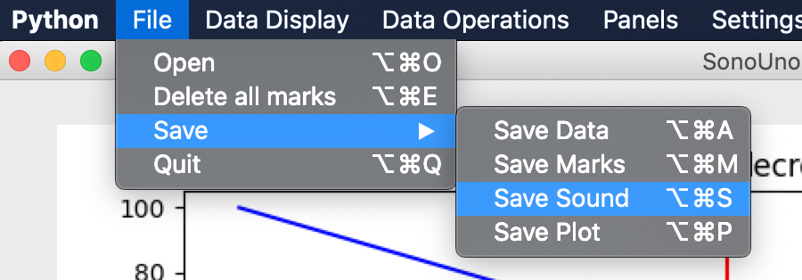

*Image 20 - Show the third option on the save submenu from the file menu, which is the save sound item.*

Like the others save option, the save sound element shows a pop-up window of the file system, where the user can choose the directory and the name of the file to save.

Finally, the user can save the plot with the save plot item on the save submenu of the file menu (Image 21), or the button save plot on the file panel on the left of the window (Image 10) (to enable the panel press the file item on the panels menu).

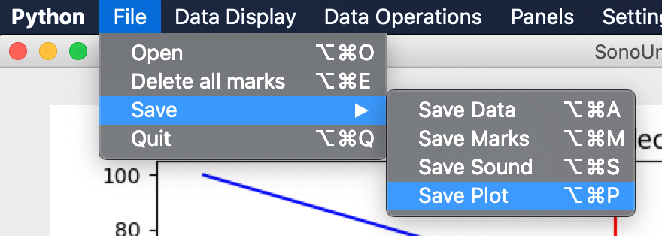

*Image 21 - Show the last option of the save submenu from the file menu, which is save plot item.*

The save plot element show a pop-up windows like the others, which allow to set the directory and the name of the file to save. To save the file press save on the pop-up window or the enter key.

The stored files have defined extensions, the data and the coordinates are saved on csv format, the plot on png and the sound on wav. As an example, an image is shown with the four files on a folder named outputs (Image 22), the icon is assigned by the operative system and the name by the user.

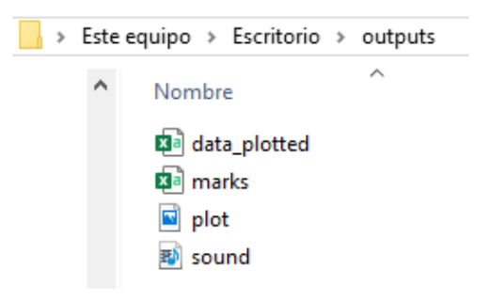

*Image 22 - Show a folder named outputs with the four saved files on the file system.*

If the user opens the coordinate file with a text editor like notepad++ (Image 23), the program shows two columns separate by coma. The first row is the name of the coordinate, for the example is x and y, and the next rows are the coordinates.

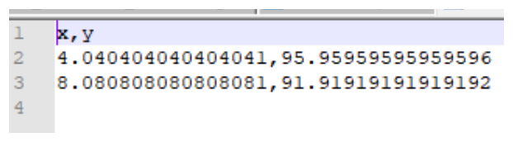

*Image 23 - Show the coordinates file saved with the button save marks. Inside the file the user can see two columns separated by a coma with the coordinates saved.*

There is an image of the plot too (Image 24). The plot file is opens with the Windows photo viewer. In addition, the Image 25 shown the sound file on the Windows Media Player.

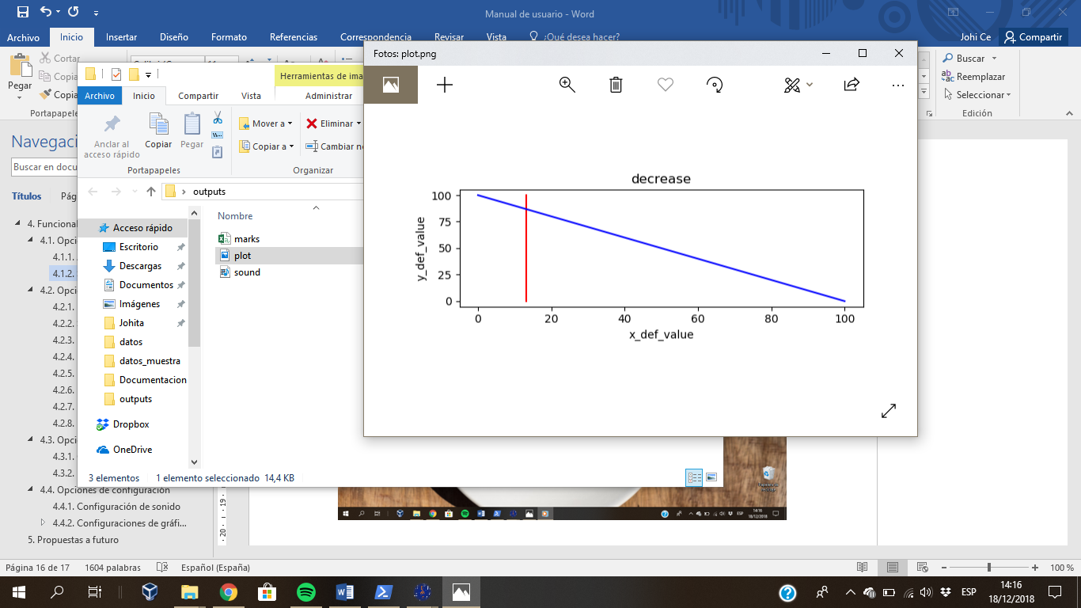

*Image 24 - Show the file of the saved plot, opened with the photos viewer of the Windows operative system.*

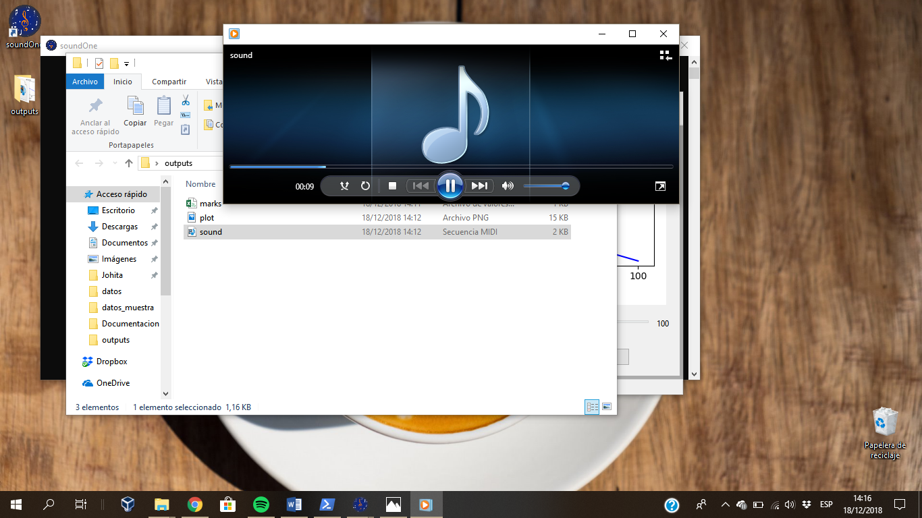

*Image 25 - Show the Windows Media Player reproducing the saved MIDI file.*

### 4.1.4. Exit the sonoUno

One way to exit the program is to press the X button on the top right of the window on Windows and the top left on Mac and Linux (Image 26). Another way is to press the quit item on the file menu (Image 27) or the shortcut key ‘Ctrl+Alt+Q’ or ‘Option + command + Q’.

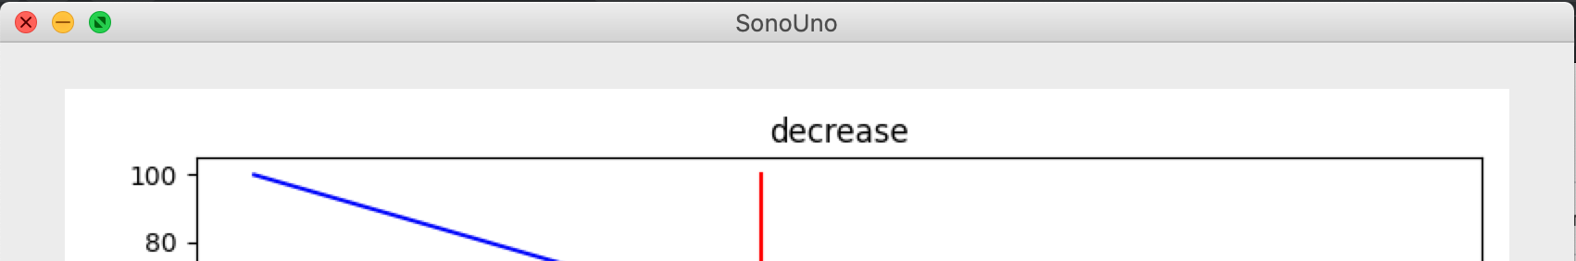

*Image 26 - Show the sonoUno interface with the mouse cursor on the X button on the top right position of the window.*

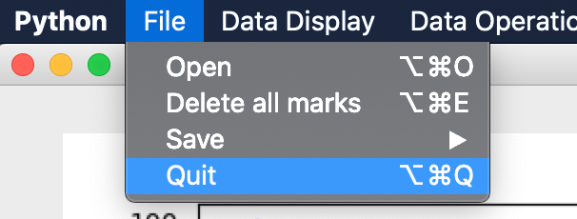

*Image 27 - Show the file menu and the focus keyboard is on the quit item.*

## 4.2. Reproduction options

### 4.2.1. Abscissas position

This functionality allows the user to move the position of the vertical red line through the data, indicating the position to reproduce when the button play is pressed.

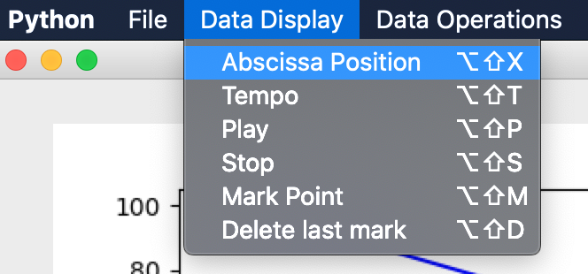

*Image 28 - Show the data display menu with its six items, the keyboard focus is on the first, which is the abscissa position item.*

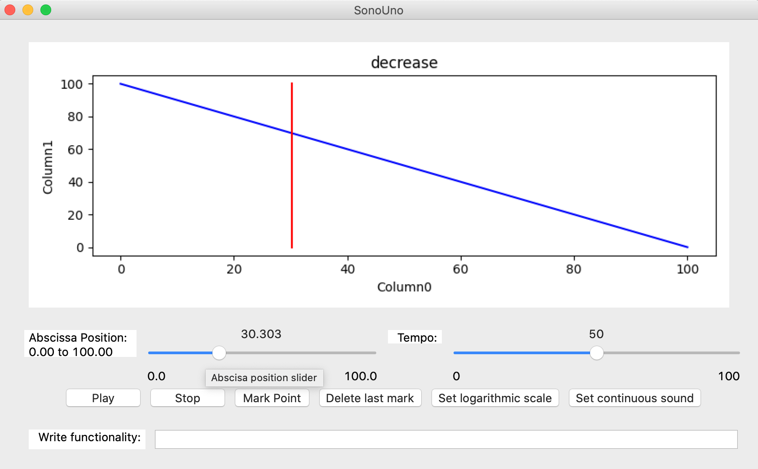

*Image 29 - The abscissa position slider is place on the left under the plot (red rectangle), the position of the slider is 17.5, and it corresponds with the vertical red line on the plot.*

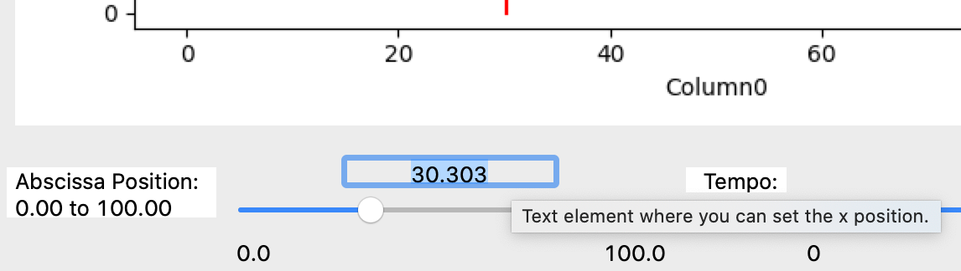

*Image 30 - Above the abscissa slider there are a text space that indicate the actual position of the reproduction and allow the user to enter a number to indicate a new position for the reproduction.*

Another way to access the abscissa position is with the abscissa position item on the data display menu (Image 28), or the shortcut key ‘Alt+Shift+X’ or ‘Option+Shift+X’. The two actions set the keyboard focus on the previous label of the slider element on the sonoUno framework. Then the user can press the tabulation key to access to the abscissa slider. The user have two options to change the position of the reproduction: on the slide bar with the mouse or the arrow keys (Image 29); and above the slider there are a text space indicating the actual value of the reproduction, you can go to this element to enter a number where you want to jump and press enter (Image 30).

The abscissa position can be modified before, during and after the reproduction of the data. If the reproduction is in progress, after change the reproduction continues from the new set value.

### 4.2.2. Tempo selection

This functionality allows to select the tempo of the reproduction of the sound, varies between 0% and 100%, being 100 the fastest and 0 the slowest time.

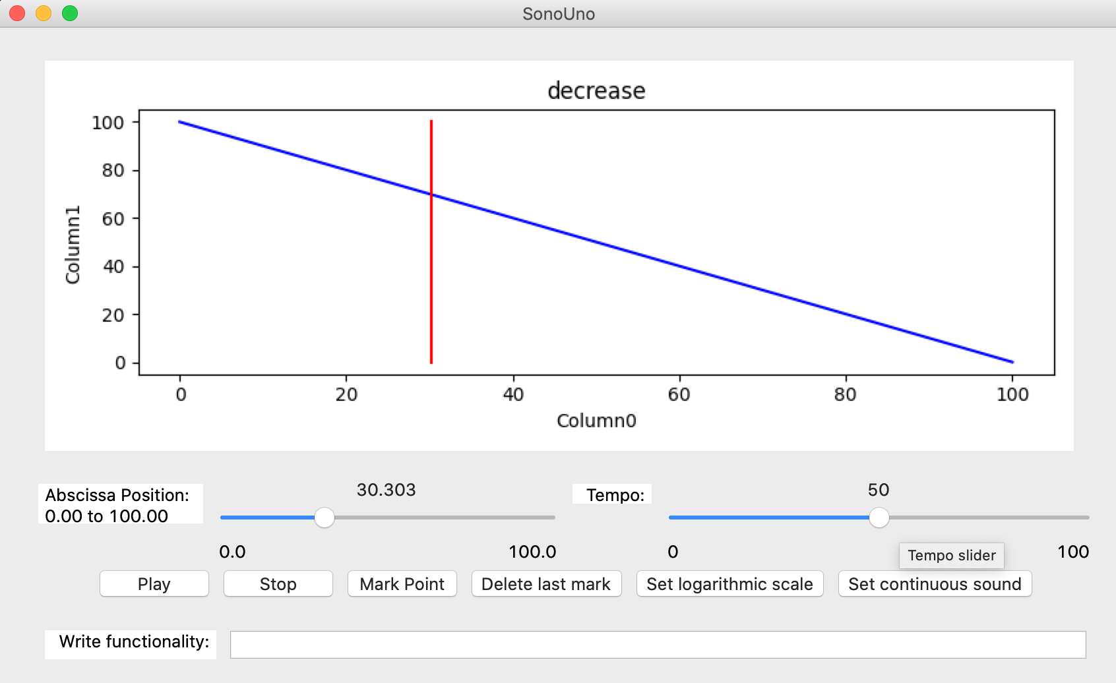

*Image 31 - The tempo slider is on the right under the plot (red rectangle).*

The tempo element is a slider with a label, placed under the plot and to the right of the abscissa slider (Image 31). The operation is analogous to the abscissa position slider. The user have two options to change the tempo: on the slide bar with the mouse or the arrow keys; and above the slider there are a text space indicating the actual value of the tempo, you can go to this element to enter a new tempo value and press enter.

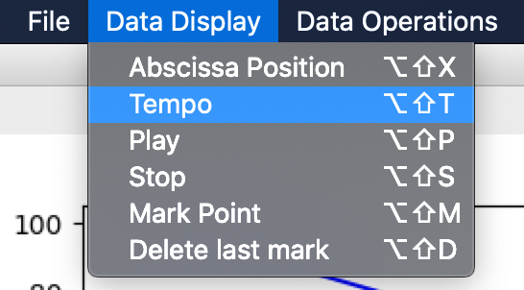

*Image 32 - Show the data display menu with its six items, the keyboard focus is on the second, which is the tempo item.*

A second way to access the tempo slider is with the item tempo on the data display menu (Image 32), or the shortcut key ‘Alt+Shift+T’ or ‘Option+Shift+T’. Those actions set the keyboard focus to the label of the tempo slider. Then the user can use the tab key to access to the tempo slider.

### 4.2.3. Play and Pause button

Is the first button of data reproduction. When is pressed change its name to Pause and start the reproduction of the data, the vertical red line and the abscissa position slider start to go forward, indicating the position of the playing coordinates.

The play button is located in the bottom left of the window (Image 33), under the sliders of position and tempo.

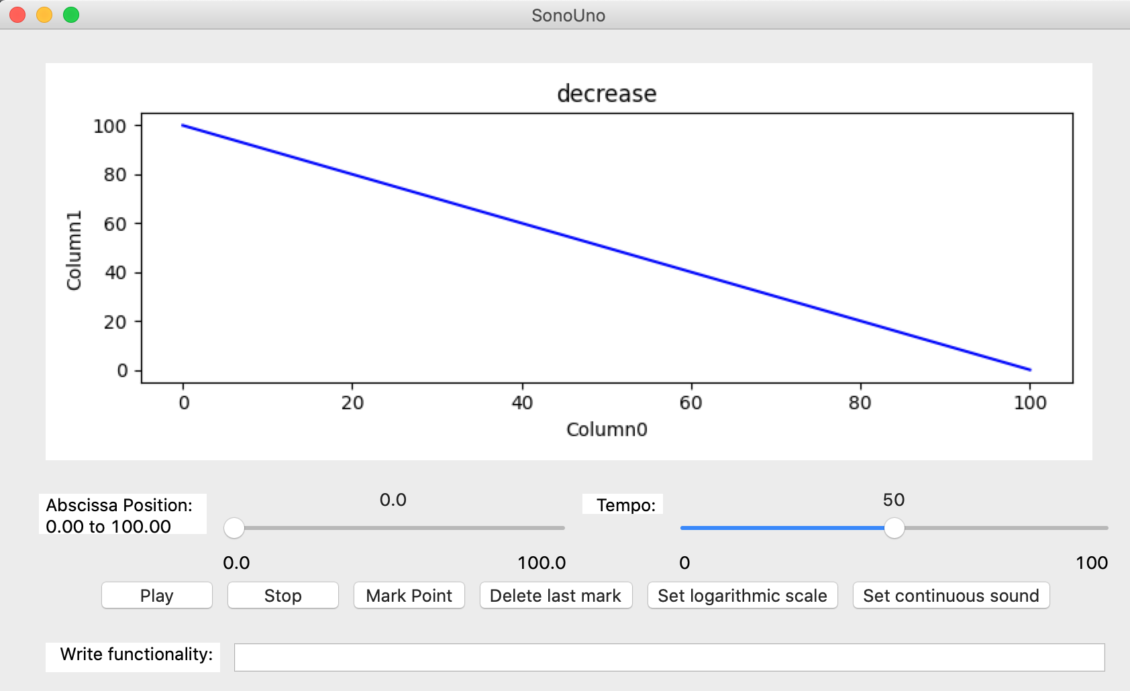

*Image 33 - The play button is found on the bottom left part, under the abscissa position slider.*

Other way to start the reproduction is with the play item on the data display menu (Image 34), or the shortcut key ‘Alt+Shift+P’ or ‘Option+Shift+P’. This item differs from the previous two, because when is pressed produce the effect directly, without modify the keyboard focus.

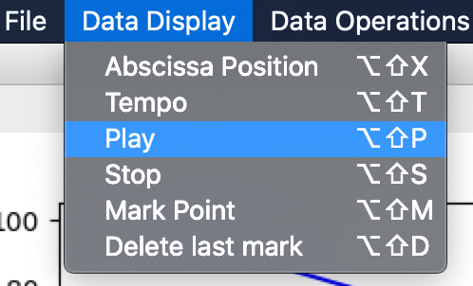

*Image 34 - Show the data display menu with its six items, the keyboard focus is on the third, which is the play item.*

To pause the reproduction of the data you have to press the same button or the same shortcut key, this action maintains the vertical red line position to be able to continue later with the play button.

### 4.2.4. Stop button

Its function is to stop the reproduction of the data restarting the process, which means that set the abscissa position to cero and delete the vertical red line from the plot. The button is placed next to the Play button (Image 35).

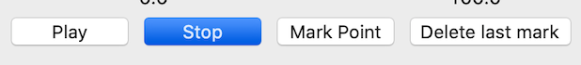

*Image 35 - The stop button is found on the bottom right part, under the tempo slider and after the delete last mark button. It's the last of the reproduction button from left to right.*

Other way to stop the reproduction is with the stop item from the data display menu (Image 36), or with the shortcut key ‘Alt+Shift+S’ or ‘Option+Shift+S’.

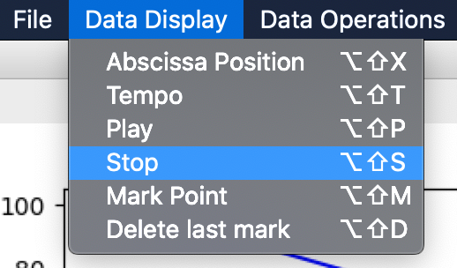

*Image 36 - Show the data display menu with its six items, the keyboard focus is on the stop item.*

### 4.2.5. Mark point button

This button allows the user to mark a specific coordinate from the data. When the button is pressed save the current position on a vector and plot it with a vertical black line. The position on the frame is on the center bottom, under the sliders of abscissa and tempo (Image 37).

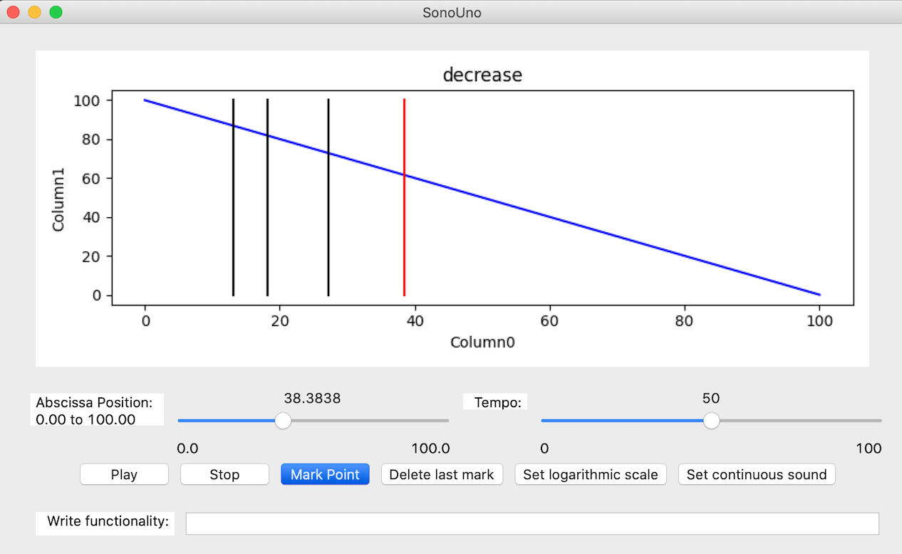

*Image 37 - The mark point button is found on the bottom center part, under the sliders and after the pause button. It's the third of the reproduction button from left to right.*

Parallel, the user can mark a point on the graph with the item mark point of the data display menu (Image 38), or the shortcut key ‘Alt+Shift+M’ or ‘Option+Shift+M’. Both methods do the same action directly without modifying the keyboard focus.

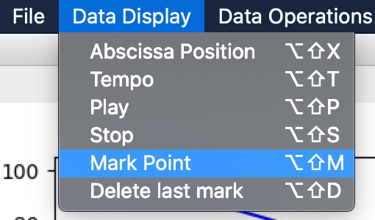

*Image 38 - Show the data display menu with its six items, the keyboard focus is on the fifth, which is the mark point item.*

### 4.2.6. Delete last mark button

This functionality allows the user to erase the last mark made with the mark point element. It’s useful when the user has made a mark without intention or the place is incorrect. The button is placed on the right bottom of the window, it’s the fourth button, after the mark point button (Image 39).



*Image 39 - The delete last mark button is found on the bottom right part, under the tempo slider and after the mark point button. It's the fourth button from left to right.*

Another way to erase the last mark point is with the item delete last mark from the data display menu (Image 40), or with the shortcut key ‘Alt+Shift+D’ or ‘Option+Shift+D’.

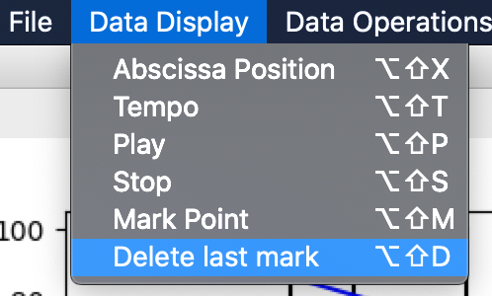

*Image 40 - Show the data display menu with its six items, the keyboard focus is on the sixth, which is the delete last mark item.*

## 4.3. Data management options

### 4.3.1. Data parameters button

The ‘Data parameters’ item from the menu ‘Panel’ (Image 41) shows a new panel on the left of the plot, this new section contains some elements that display the data file in columns and allow the user to change the title of the data, change the columns titles and select which column plot as X axis and which as Y axis.

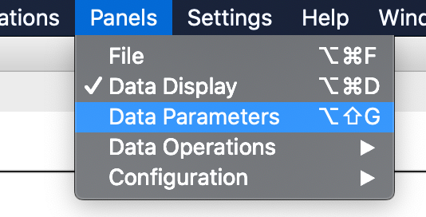

*Image 41 - Show the items of the menu Panels and the focus keyboard is on the Data Parameters item.*

When import a file ‘decrease’ for example (this file is on the ‘sample_data’ folder), the data title text box shows the data file title, the data values are shown in the grid, and the first-row values of each column are shown in the axis list selection (Image 42).

The first row of this file doesn’t contain the title of each column, the program put the generic name ‘Columnx’ on this case. On the grid the user can change the column names. Finally, to save the changes the user has to press the ‘Update column names’ button and the new columns titles have to be shown on the axis selections (Image 43).

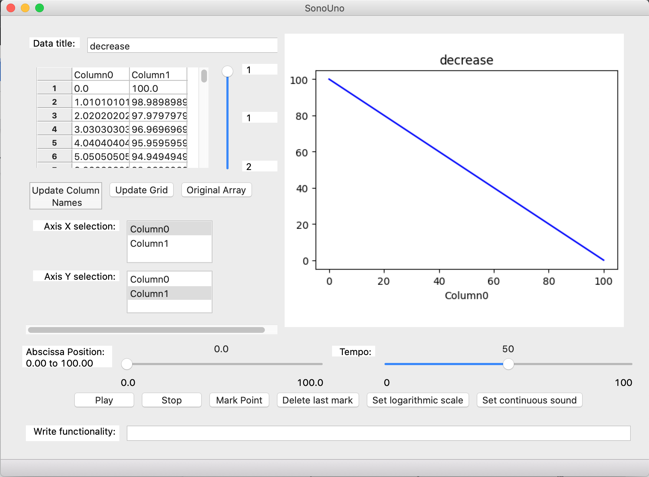

*Image 42 - Shown the elements that allow to change the titles and select the axis with values of 'decrease' file.*

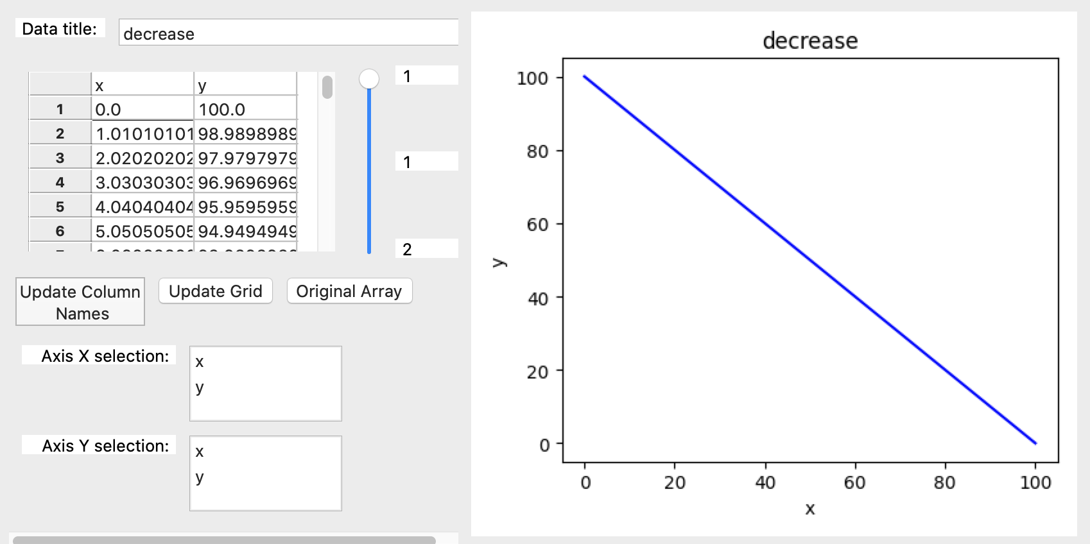

*Image 43 - Shown the new columns titles set by the user.*

The ‘Update grid’ button show the two columns plotted, just in case the user want to display the data after some mathematical function. Finally, the ‘Original array’ button allows to show the original data again.

For the next example, a galaxy data file was download from the Sloan Digital Sky Survey database and opened with the software (Image 44). Link: <http://skyserver.sdss.org/dr15/en/tools/quicklook/summary.aspx?id=1237648720693755918>

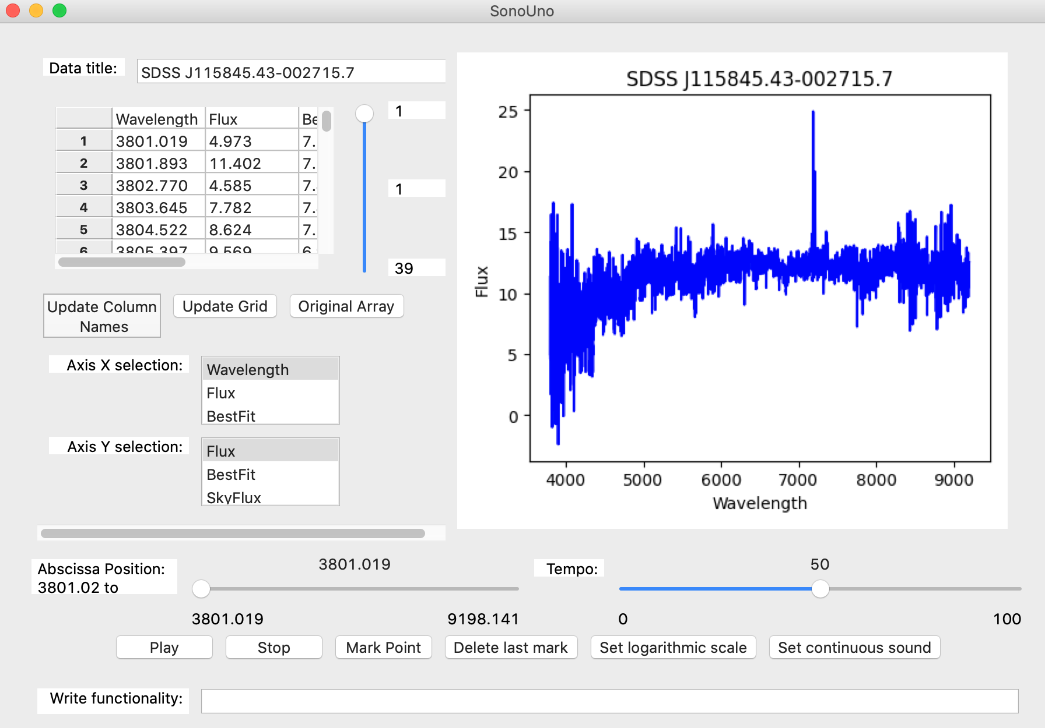

*Image 44 - Show the download data opened on the software.*

This new file has the column title on the first row, the user can modify the titles or change the column to plot, for example maintain Wavelength as X axis, and change to Best Fit on the Y axis (Image 45).

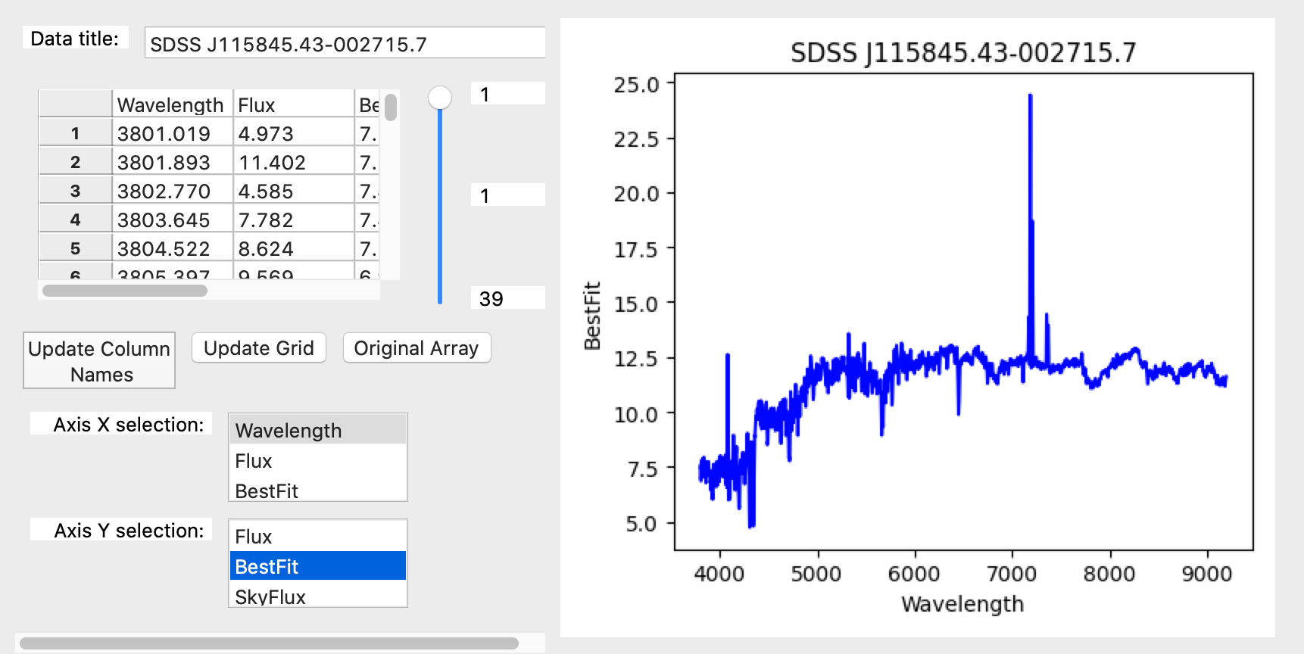

*Image 45 - Show the change on the Y axis from Flux to BestFit.*

**NOTE:** The user has to keep in mind that this changes only have effects on the software, the file opened didn’t change and only the data plotted can be saved by the software.

When the data file present more than 100 rows, the software load the data in pages of 100 values each one, and you can change between pages with the slider bar at the right of the grid (Image 46).

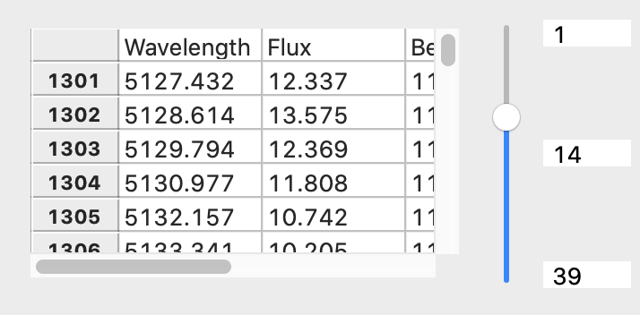

*Image 46 - Data grid on the page 14 of the data, selected with the vertical slider bar at the right..*

At the moment the sonoUno was tested with a two column data with 1 million rows. These among of data was loaded without problems.

### 4.3.2. Cuts on the abscissa’s axis

The sonoUno presents some possible operations with the data. In this case, it is explained the abscissas cut function, which allow to cut the abscissas axis between the data limits and select a range of interest. One way to access the cut sliders is from the horizontal limit submenu of the data operation menu (the items are lower limit for the horizontal inferior limit and upper limit for the horizontal superior limit) (Image 47). Each one of the actions enable the sliders and mathematical functions panel and set the keyboard focus on the respective label, then with the tab key or the mouse the user can focus on the slider.

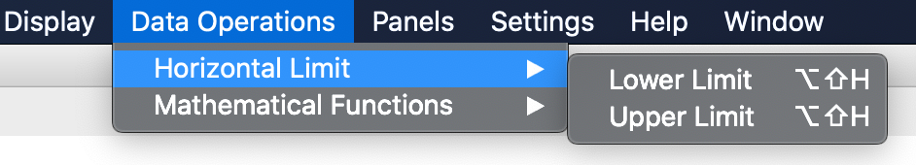

*Image 47 - Show the horizontal limit submenu of the data operations menu, where are two options: lower limit and upper limit.*

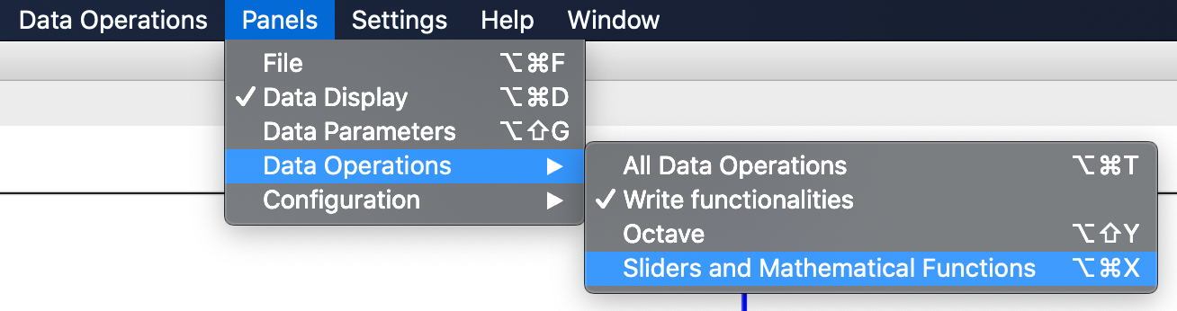

*Image 48 - Show the data operation submenu of the panel’s menu, where the user can enable and disable the sliders and mathematical functions panel with the item of the same name.*

The second way to access the cut sliders is enable the corresponding panel with the sliders and mathematical functions item on the Data operation submenu from the panel’s menu (Image 48). When this item is checked the cut sliders and mathematical functions panel is shown, this panel is placed under the reproduction buttons described above (Image 49).

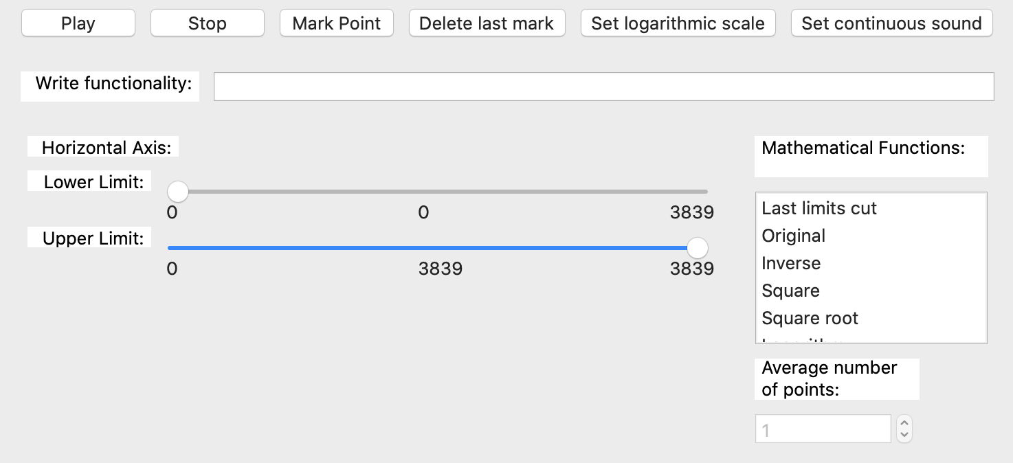

*Image 49 - Show the panel of sliders and mathematical functions in a red rectangle. Inside this section the user can find the cut sliders and some predefined mathematical functions.*

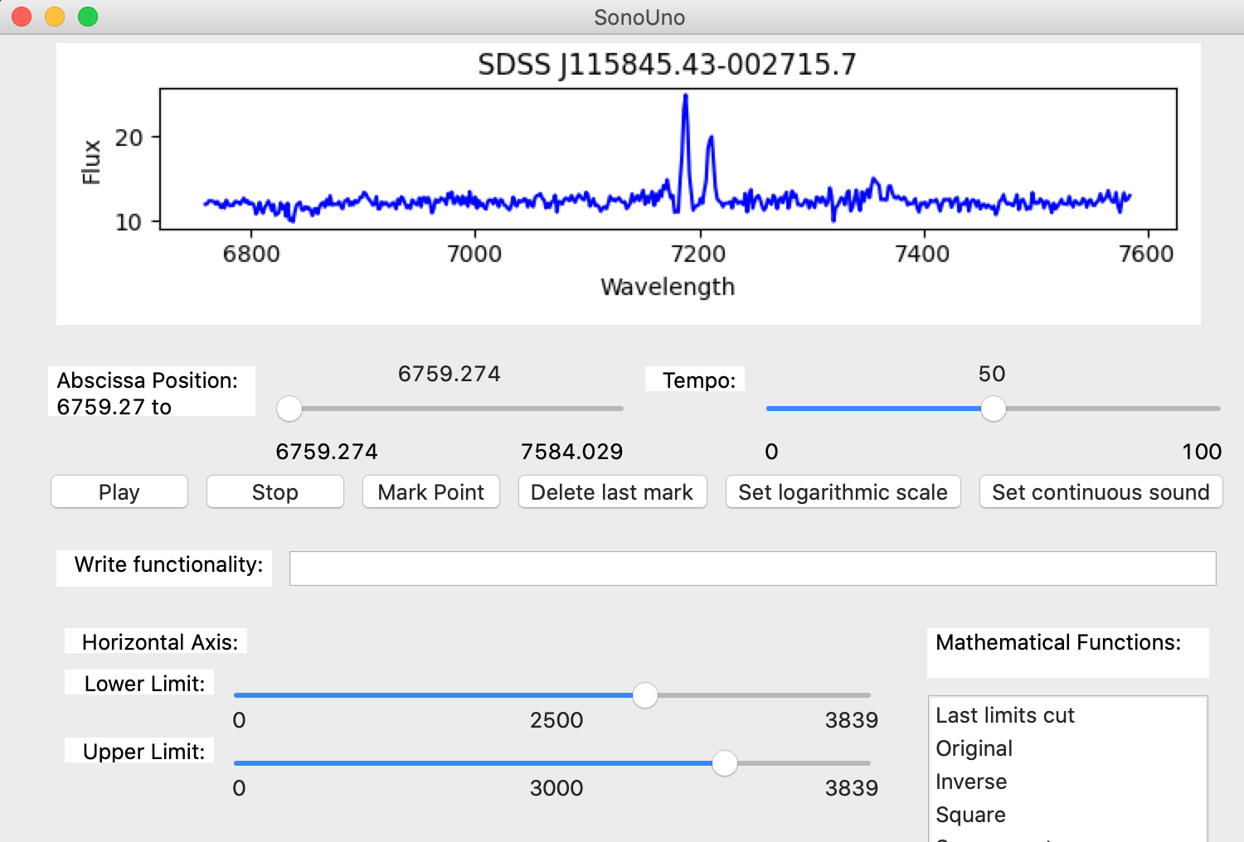

*Image 50 - Show an example of the cut sliders, the lower limit is set to 2500 and the upper limit is set to 3000. The user can perceive the changes on the cut sliders and the plot.*

The left part of the mentioned panel contains the cut sliders, those sliders can be set by the mouse or the arrows keys. Is important that the lower limit not be upper that the upper limit or vice versa, if that is the case there are not visible error but the sliders do not modify the limits on the plot.

The Image 50 is an example of cut limits, the inferior cut value is 2500 and the superior cut value is 3000. It must be notice that when the user does a cut on the data, the plot is updated to the new values for refill the available space.

**NOTE:** The number of the sliders represent the position of the data value, not the value itself.

### 4.3.3. Mathematical functions

#### 4.3.3.1. Predefined functions

In this section other possible data operations are shown, those are some predefined mathematical functions like inverse, square, square root, logarithm and average. In the last, the user must indicate the number of values to consider for calculate the average.

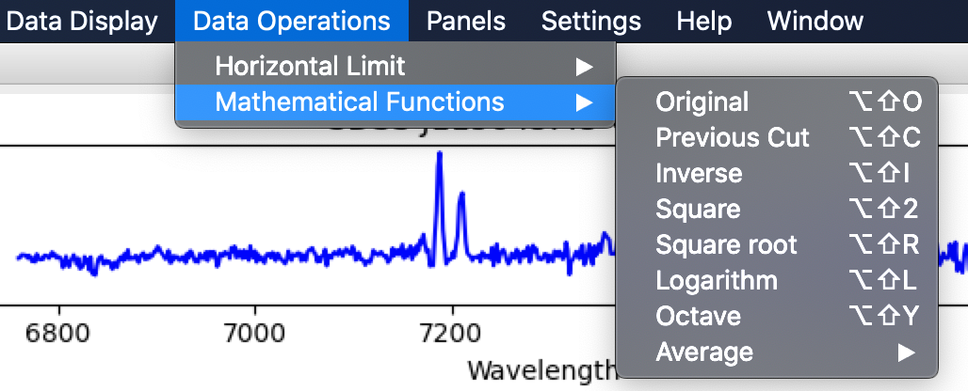

*Image 51 - Show the mathematical functions submenu of the data operation menu, with its six items of the predefined functions.*

There are two ways to access the mathematical functions, one is with the mathematical functions item from the data operations menu (Image 51), which have the functions items; the other way is with the sliders and mathematical functions item from the data operation submenu in the panels menu (Image 48). The items on the submenu mathematical functions and the items from the mathematical functions list on the sonoUno framework (Image 52) do the action when each one is pressed. The average item enables the number of points text box for select the number of values to be consider on the average calculus, by default is 1.

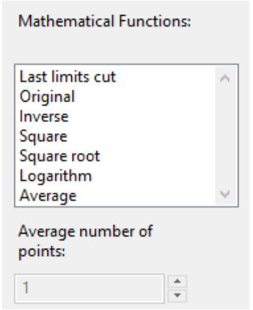

*Image 52 - Show the list of predefined mathematical function, are the same of the previous image. The text box of the bottom will be enabled with the average function and allow to set the number of points.*

Coming up next, the mathematical functions are applied to a decreasing function with 100 values. The example starts with the decreasing function, lower limit set to 20 and upper limit set to 80.

The functionality named ‘Original’ allow to restore the plot to the original data without modifying the cut limit sliders. It’s useful for display the original data (Image 53).

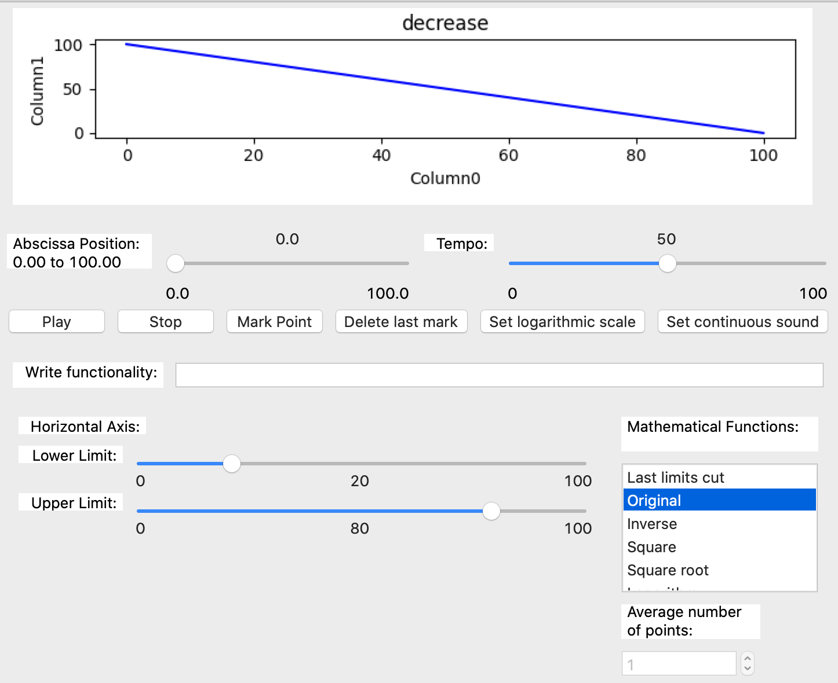

*Image 53 - The original function is selected; the cut limit sliders remains on the same position but the limits of the data on the reproduction and plot are the original.*

The functionality named ‘Last limit cut’ is to recover the last cut limits values set by the user (Image 54). When is pressed after the ‘Original’ function, the plot is redraw with the previous upper and lower limits. On the example the upper limit is 80 and the lower limit is 20. Is useful to alternate with the original function, the user must to have in mind that is not possible to restore a previous cut value after change a cut slider.

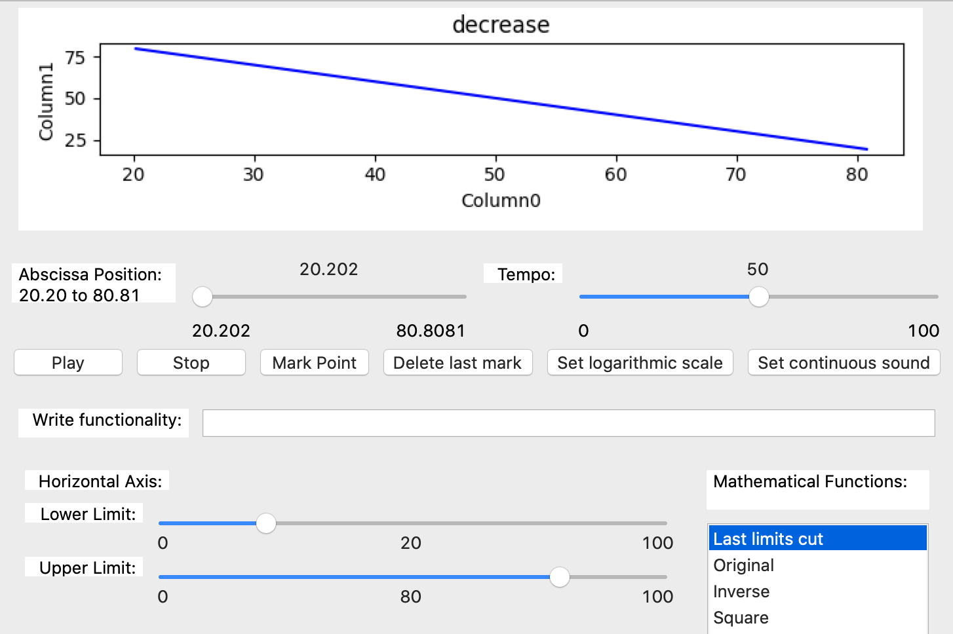

*Image 54 - The last limits cut is selected, the data for the reproduction and the plot have the same limits of the cut sliders again.*

The inverse function reverses the ends of the y axis (Image 55). It’s notice that all the mathematical functions are calculated based on the original data and do not allow to cut the x axis. The two next functions perform the square (Image 56) and square root (Image 57) to the original data. The logarithm item applies this function to the original data (Image 58).

Finally, the average function or smooth uses the number of points entered by the user for group the data and calculate the average on the original data. For example, if number of points is 6, the algorithm groups the first 6 values, calculate the average between them and replace all the 6 point by the new value; then, continue with the next 6 values and do the same (Image 59).

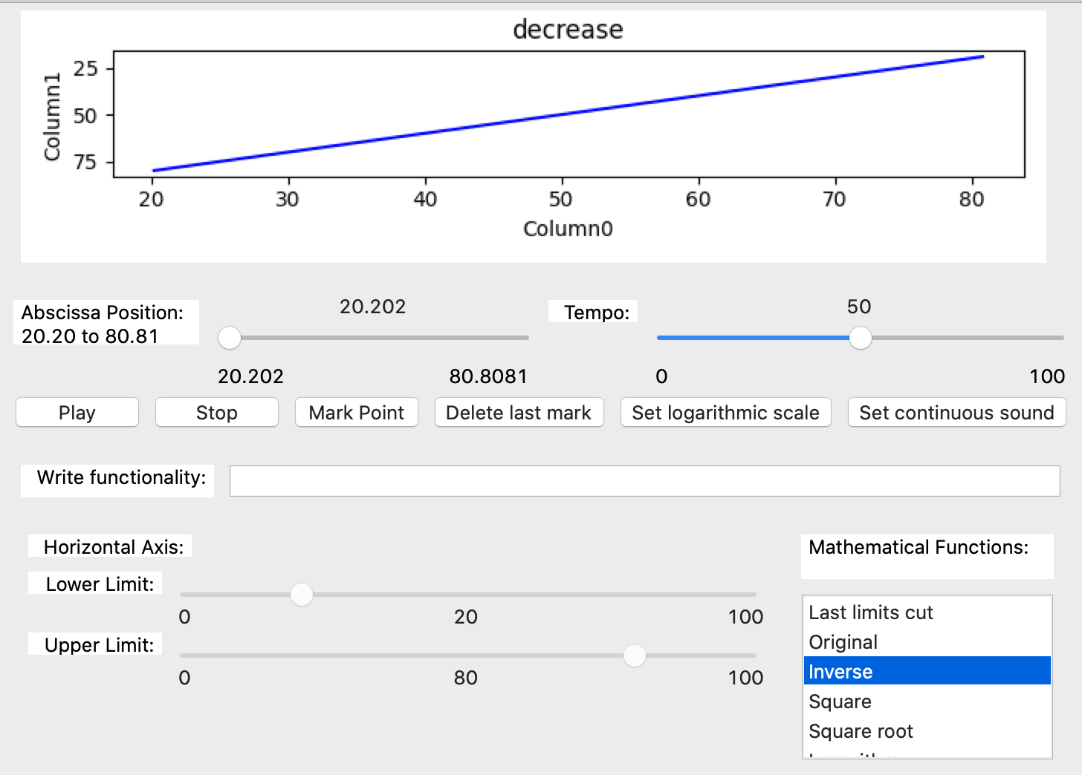

*Image 55 - The inverse function is selected; the data has been reversed with respect to the ordinate axis.*

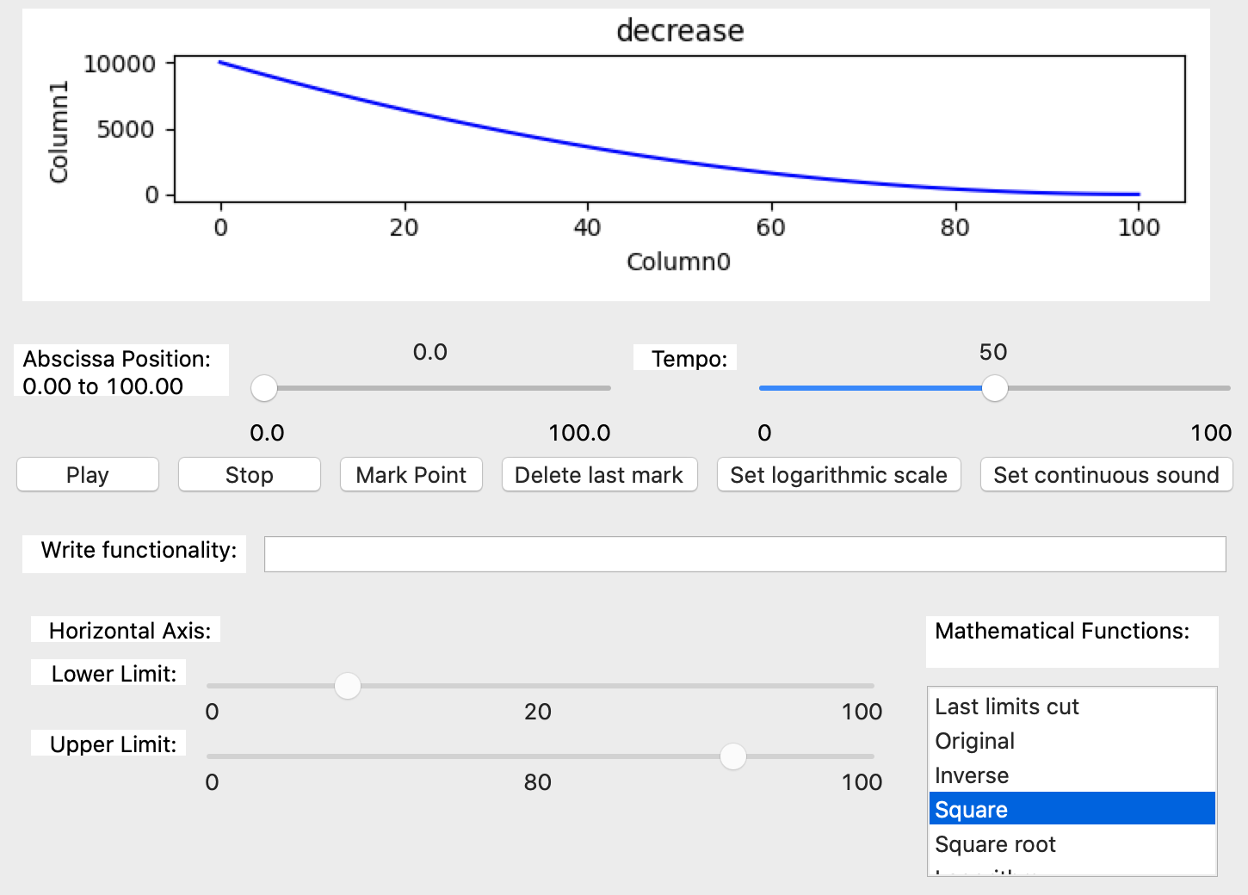

*Image 56 - The square function is selected. The image shows the square of the decreasing function.*

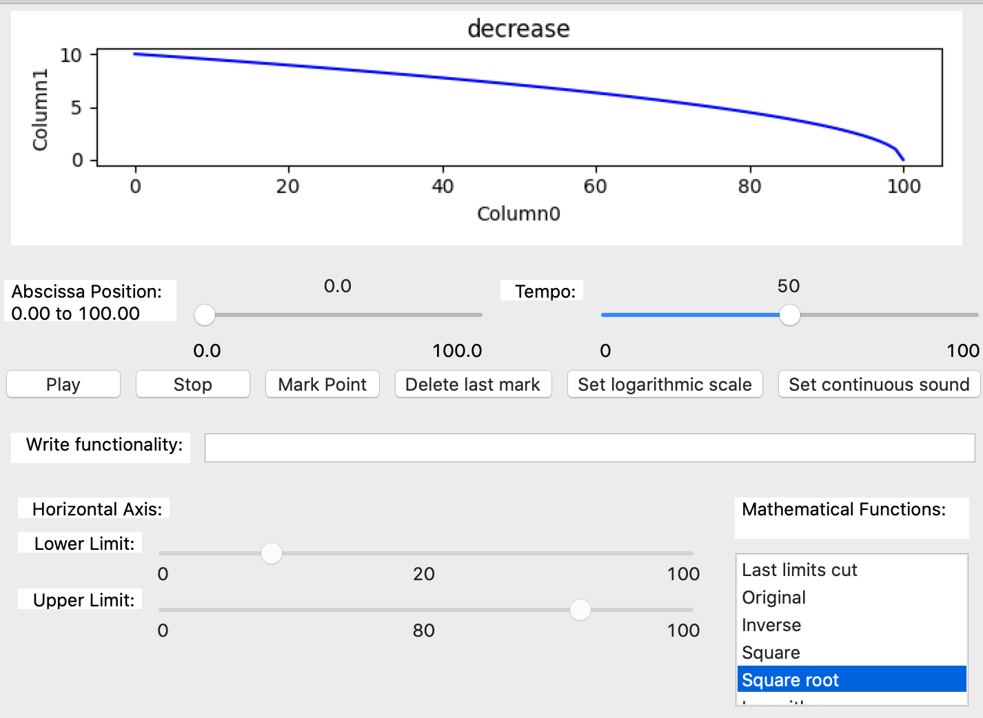

*Image 57 - The square root function is selected. The image shows the square root of the decreasing function.*

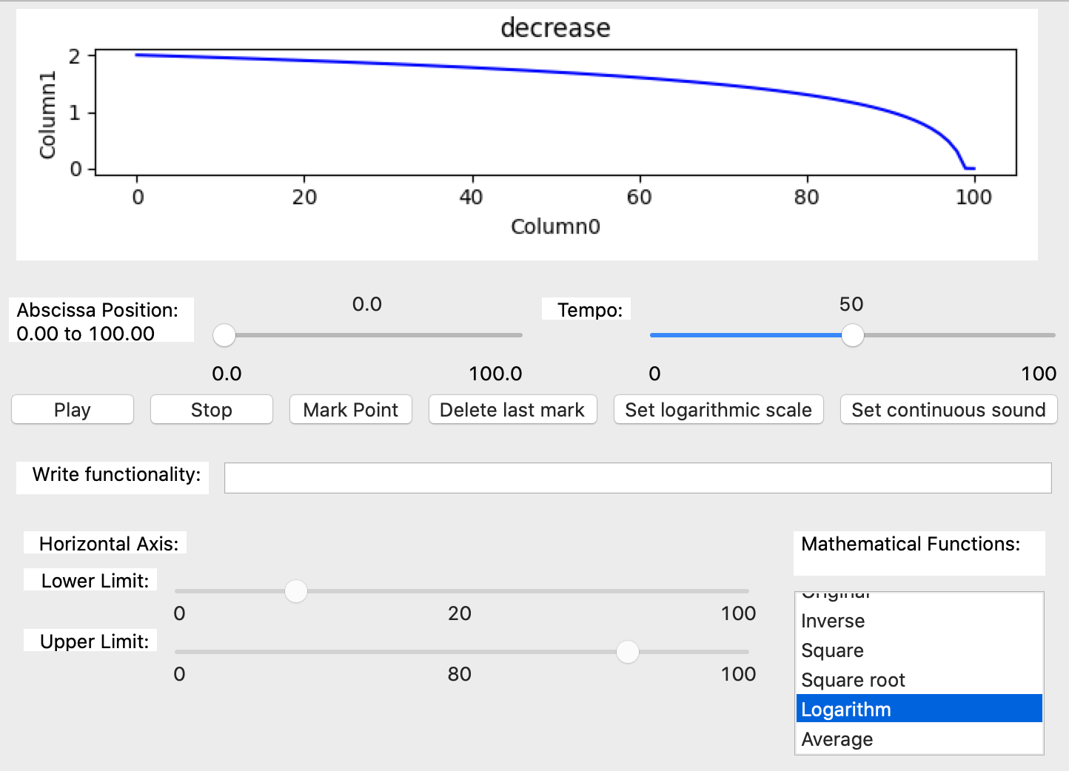

*Image 58 - The logarithm function is selected. The plot shows the logarithm of the decreasing function.*

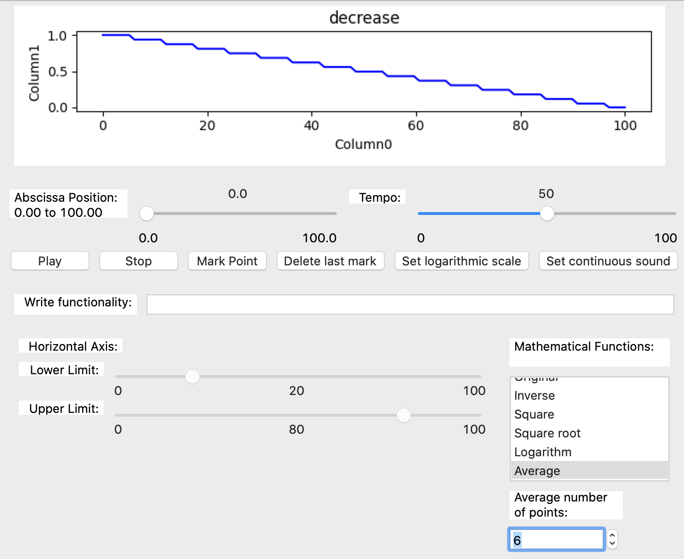

*Image 59 - The average function is selected. The text box under the mathematical functions list are enable. In the image the number of points to set the average are six.*

#### 4.3.3.2. Write functionalities

This option allow the user to write different functionalities of the software directly on a text element (Image 60). The functionalities are predefined and we put the list that the software allow at the moment on the next paragraph.

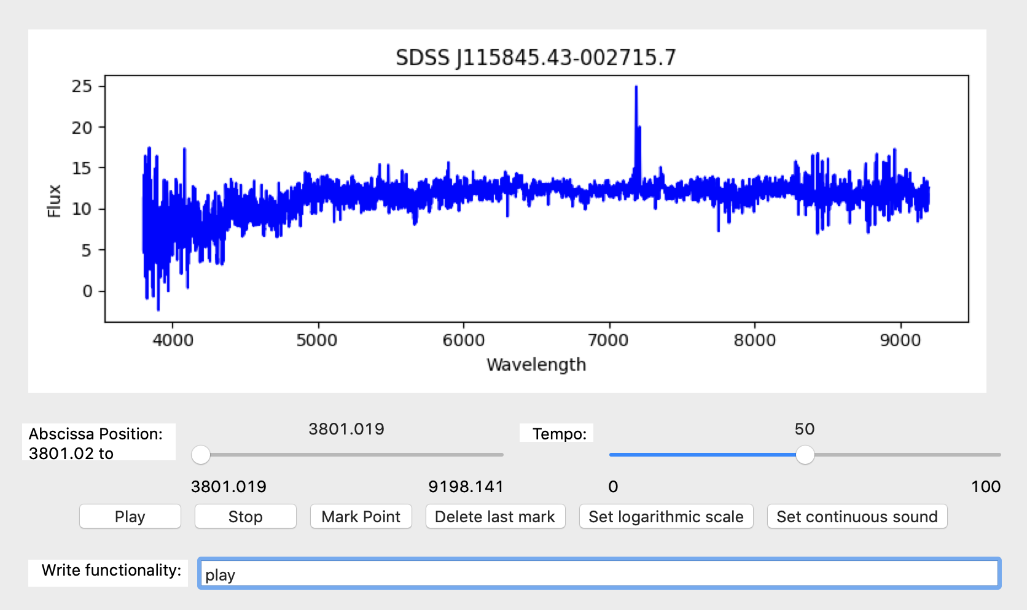

*Image 60 - Shown the first framework of the software with the element write functionality with the function play written in it. This element was placed at the bottom of the framework.*

The different functionalities to write on the element are:

* open
  + produce the same action that the file - open item placed on the menu bar.
* dellastmark
  + delete the last mark performed on the data by the user.
* delallmarks
  + delete all the marks performed on the data.
* savedata
  + save the data plotted on the graph, for that this action open the file system window and allow to write the name of the file.
* savemarks
  + save the marks performed on the data, for that this action open the file system window and allow to write the name of the file.
* saveplot
  + save the plot, for that this action open the file system window and allow to write the name of the file.
* savesound
  + save the sound, for that this action open the file system window and allow to write the name of the file.
* ‘quit’ or ‘exit’
  + close the software
* play
  + reproduce the data sonification.
* pause
  + pause the reproduction and maintain the position of the last data sonified.
* stop
  + stop the reproduction and restore the default position to sonify to the beginning of the data.
* markpoint
  + mark a point on the actual position of the reproduction.
* originaldata
  + plot the original data imported.
* xlastcut
  + plot the last cut on the x axis performed by the user.
* inverse_mf
  + invert the y axis on the plot.
* square_mf
  + apply the square function to the y axis.
* squareroot_mf
  + apply the square root function to the y axis.
* logarithm_mf
  + apply the logarithm function to the y axis.
* xposition(pos)
  + allow to jump to an specific value of the x axis on the data.
* tempo(percentage)
  + allow to set the tempo with a number between 0 and 100.
* xlowerlimit(lower_limit)
  + allow to set the new lower limit on the x axis.
* xupperlimit(upper_limit)
  + allow to set the new upper limit on the x axis.
* octave(command)
  + allow to use octave commands write between parenthesis.
* fromoctave(variable_x, variable_y)
  + allow to return two variables from octave and set they as x value and y value.

If the element don’t appear on the framework, it can be shown from the menu Panels, submenu Data Operation, item Write functionalities (Image 61).

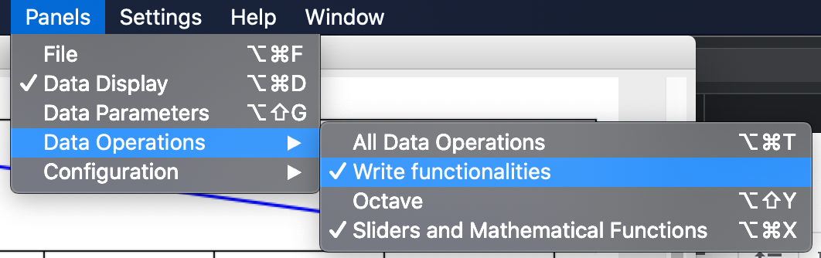

*Image 61 - Show the Data Operations submenu of the menu Panels, where are four items and the keyboard focus is on the Write functionalities item (second place).*

#### 4.3.3.3. Octave functionality

Here we introduce how to use the sonoUno’s octave functionality. Now to apply different commands the user have to use the ‘Write functionalities’ element (Image 60) and write ‘octave(one_command)’. The output of octave is show on the octave panel. For more information about Octave itself follow the link to proper the documentation (<https://octave.org/>).

**NOTE:** When the user opens some data on the software, automatically the first two columns of the data are sent to octave with the names x and y. In addition, all the columns are sent to octave with the columns names as variables names. Then, when the user makes some changes on the data, the variables x and y are updated on octave. This is important, because the user do not need to make any steps to send the plotted data to octave, instead the software perform this task automatically, and conserve the original data with the columns names.

To open the octave panel, you have to go to the menu Panels, then submenu Data operations, and finally, the item Octave (Image 62). Other way to open it is with the Octave item from the submenu Mathematical functions on the Data operations menu (Image 63).

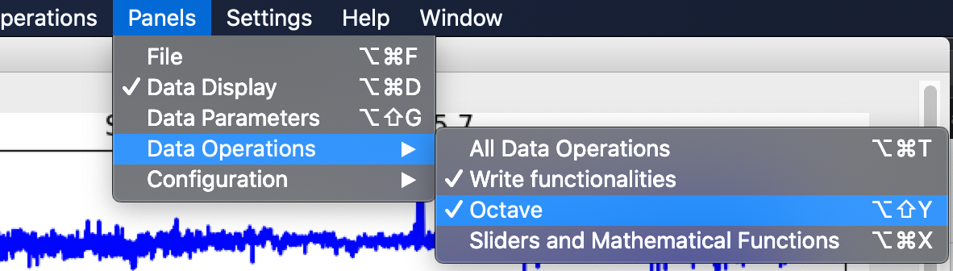

*Image 62 - Show the Data Operations submenu of the menu Panels, where are four items and the keyboard focus is on the Octave item (third place).*

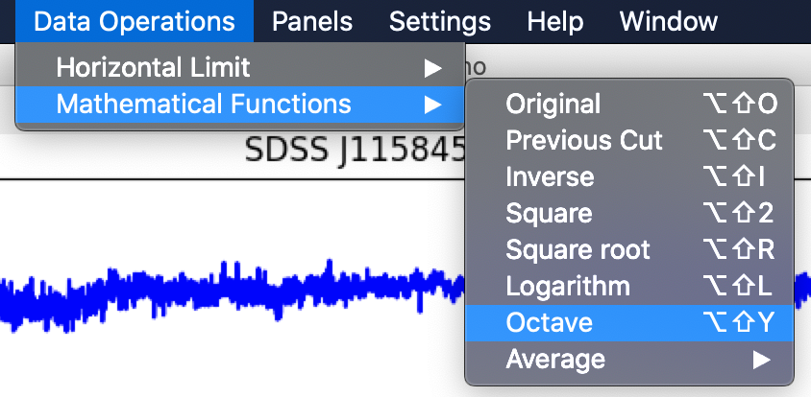

*Image 63 - Show the Mathematical functions submenu of the menu Data operations, where are eight items and the keyboard focus is on the Octave item.*

When this item is checked, the octave panel is shown (Image 64). This panel is located under the Write functionality element and above the mathematical function panel.

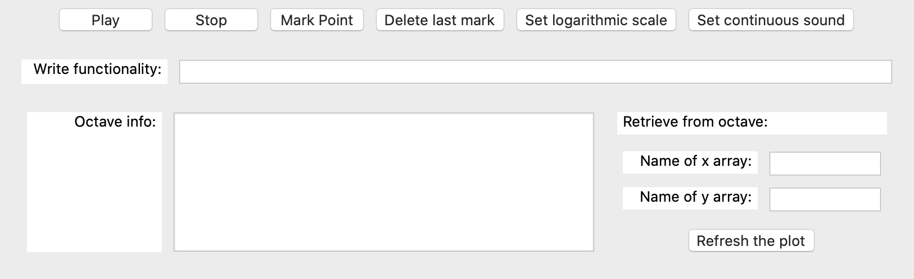

*Image 64 - Shown the octave panel in a red rectangle. Inside this section the user can find the octave text box, the info box and the retrieve from octave section, all with their corresponding labels.*

On the left of this panel contains an information text box and its label “Octave info”, where the software writes the octave output. On the right of this panel, the retrieve from octave section is located. The first row displays the label and the second row, contain the text box to write the name of the variable to place on x axis and its label ‘Name of x array’. Then, the third row present the same elements but for the y axis. Finally, there are a button named ‘Refresh the plot’, which one display the new variables on the plot section.

## 4.4. Configuration options

The sonoUno allow the user to adjust some sound and plot settings, these functionalities are in the settings menu (Image 65), or the all configuration item on the configuration submenu from the panels menu (Image 66).

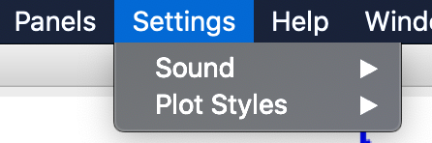

*Image 65 - Show the menu setting with its two submenus: sound and plot style.*

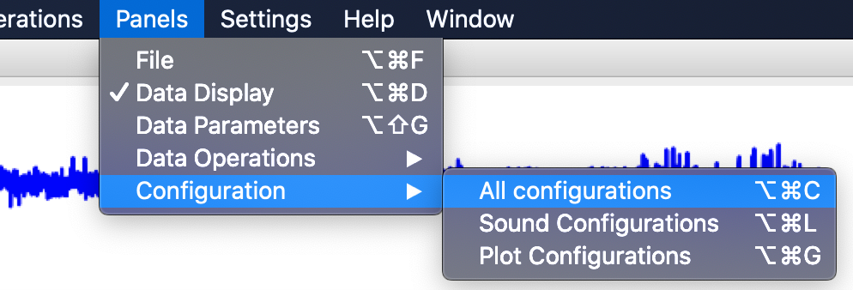

*Image 66 - Show the configuration submenu of the panel’s menu, where are three items and the keyboard focus are on the all configurations item (first place).*

Both options show the configuration panels on the left of the interface, under the file panel if it is enabled. If we check the item all configurations, but the items sound configurations and plot configurations are unchecking, the configuration panel only shown the toggle buttons of sound configurations and plot configurations (Image 67). With these buttons the user can show or hide the particular configurations.

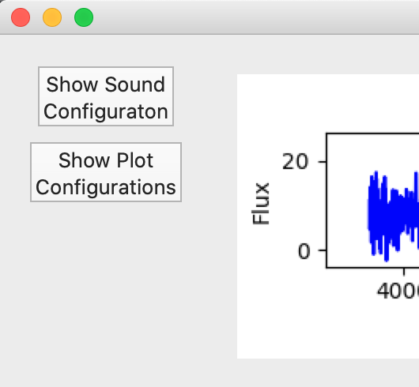

*Image 67 - The all configuration item from the previous image enable or disable the configuration panel, which is placed on the top left of the sonoUno frame and contain the toggle button for sound and plot configurations.*

### 4.4.1. Sound configurations

There are three ways of access to the sound configurations, one is with the items in the sound submenu from the settings menu (Image 68), the other with the sound configurations item in the configuration submenu from the panels menu (Image 69), and finally, the show sound configuration button from the configuration panel in the left of the window, explained on the previous section (Image 67).

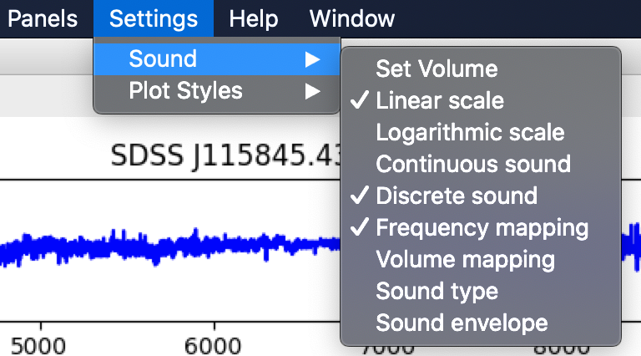

*Image 68 - Show the sound submenu of the setting menu, where are two items: volume and sound type.*

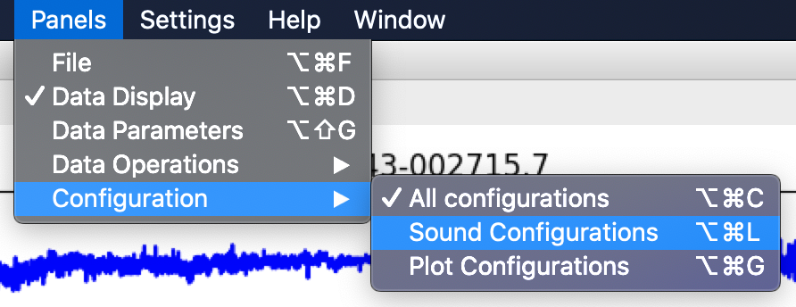

*Image 69 - Show the configuration submenu of the panel’s menu, where are three items and the keyboard focus is on the sound configurations item (second place).*

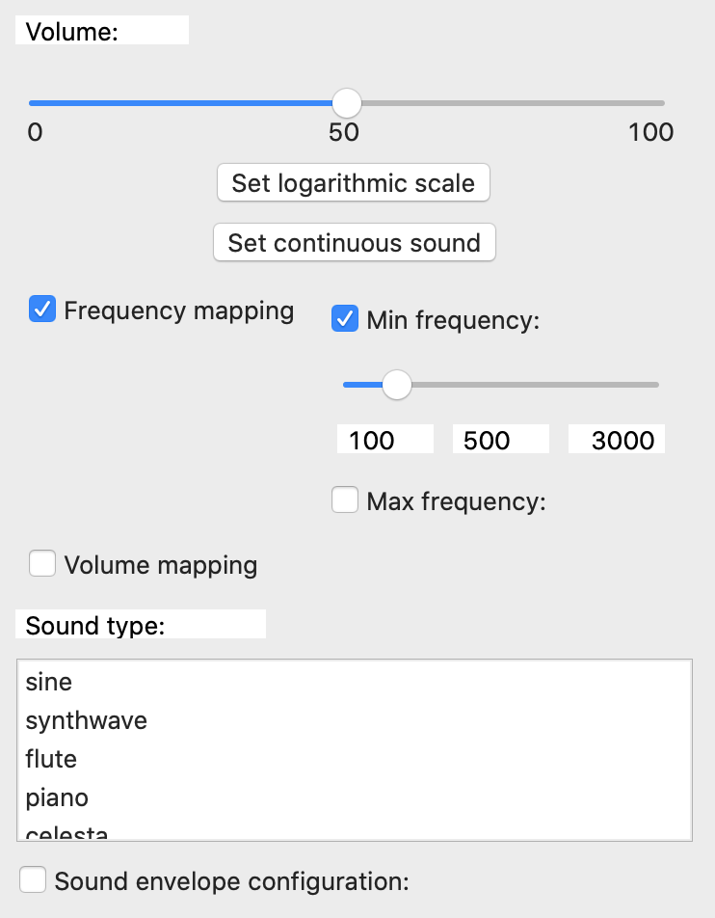

*Image 70 - Shown the sound configurations panel, which is on the left of the window and contain the sound configuration elements.*

Once the sound configuration section is shown on the left of the window (Image 70), the user can access the configuration elements, the first part is a slider with its label to set the volume of the sound.

Next, a button allows for the selection of linear or logarithmic mapping of the represented variables into a sound feature (frequency or volume).

A second button can be used to load some sound preset configuration better suited for playing continuous sounds or discrete sound steps.

A checkbox allows for the selection of frequency mapping (at fixed volume) and two sliders can be used for setting minimum and maximum frequency to use for the variable mapping.

Another checkbox sets the mapping to volume at a frequency that can be selected with a slider, as well as the minimum and maximum volume to use for the variable mapping.

The next combo box, with a list, allows the user to choose between some sound types to use. These sounds are not intended to sound like real instruments, but rather just loosely recall those instrument's sounds in order to present the user with some distinguishable options.

**NOTE:** All the sliders inside the mapping configuration must be enabled and disabled with checkboxes, this is to ensure a better navigation with the screen reader and a lower memory overload.

#### 4.4.1.1. Special sound configurations

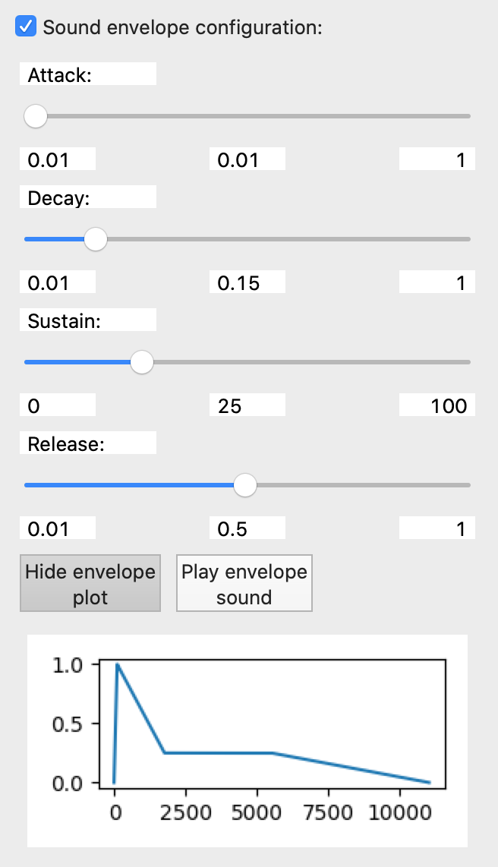

*Image 71 - Show the sound envelope configuration with its four sliders (attack, decay, sustain, release), some buttons to show and sonify the envelope and the envelope plot.*

This configuration uses a standard approach of wave envelope called ADSR (Image 71), which controls four variables:

**Attack:** the time it takes for the wave intensity to rise from silence to the peak volume. The shorter this time, the more the sound resembles a strike or percussive sound (like a piano, or xylophone). A longer attack will result in a softer sound.

**Decay:** right after the peak is reached, the intensity takes this time to fall to a sustain level. A short decay time results in a more discrete like sound, whilst a longer decay gives longer, yet not continuous sound.

**Sustain:** once the decay time ends, the intensity is held at this value. It gives the sensation of instrument resonance. A high sustain level will yield a continuously playing sound, as the volume will not get low. This value can even be set to zero, so that the sound will just seem like something is hit, with no resonance at all.

**Release:** ending the sound abruptly not only generates artifacts in the sound hardware, but also sounds odd. The release time is what the sound takes to fade from the sustain level to silence.

The best way to learn how these parameters affect the sound is playing with it. SonoUno can update and feed these parameters in real time so that the user can modify them and hear the effects immediately.

### 4.4.3. Plot configurations

The plot configurations given are the plot style (line, marker and color) and grid option. To access the plot configurations panel, exist three ways, one is the plot style submenu from the setting menu, where are the items plot line style, plot marker style, plot color style and grid options (Image 72). Other way is the plot configurations item on the configuration submenu from the menu Panels (Image 73). In addition, if the all configuration panel is enabled (section “5.4. Configuration options”) (Image 66), the user can utilize the show plot configuration button (Image 74), which when is pressed change the name to hide plot configurations and allow to hide the plot settings.

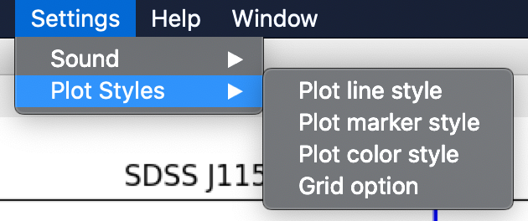

*Image 72 - Shown the plot style submenu of the setting menu, which contain the different styles that the user can set.*

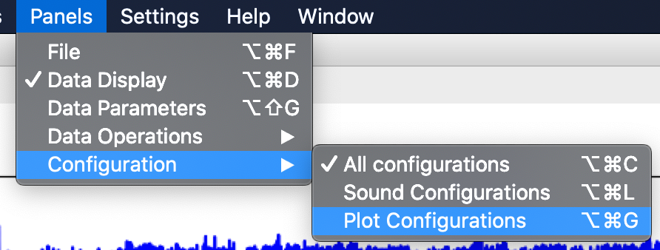

*Image 73 - Shown the configuration submenu of the menu Panels, which contain three items and the keyboard focus is on the plot configurations item.*

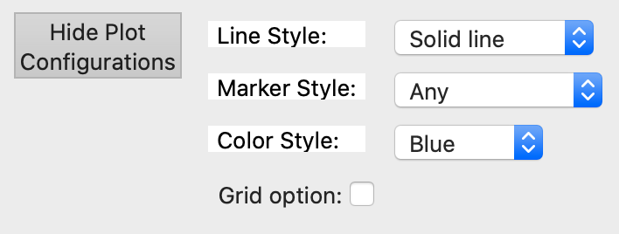

*Image 74 - Shown the plot configuration panel (red rectangle), where the user can choose between different line styles, markers and colors. In addition, the grid option can be selected.*

#### 4.4.3.1. Styles of the data plot

On the plot configuration panel, after the line style label, is placed the drop-down list with five options of style, which are: discreet, solid line, dashed line, dash-dot line and dotted line. In the example of the Image 75 the dash-dot line style is shows, with blue color and without markers.

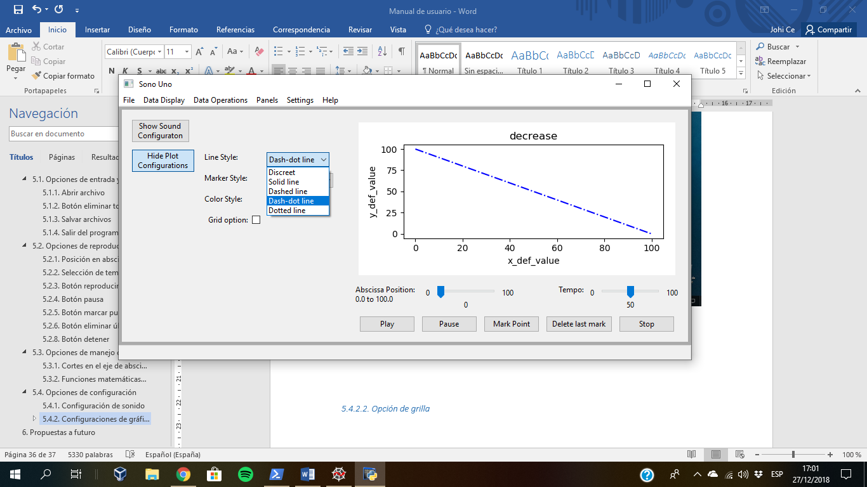

*Image 75 - The line style element is a drop-down list, where are five options. In the image the dash-dot line style is selected.*

Analogously to the line style, after the marker style label, is found the drop-down list with different options of markers, some of them are: Point, Circle, Triangle down and Tri up. In the Image 76 is used the triangle down marker, with the discreet line style and the color blue.

Next, after the color style label, is placed the drop-down list with seven colors: blue, green, red, cyan, magenta, yellow and black. In the example of the Image 77 is used the red color, with the solid line style and the point marker.

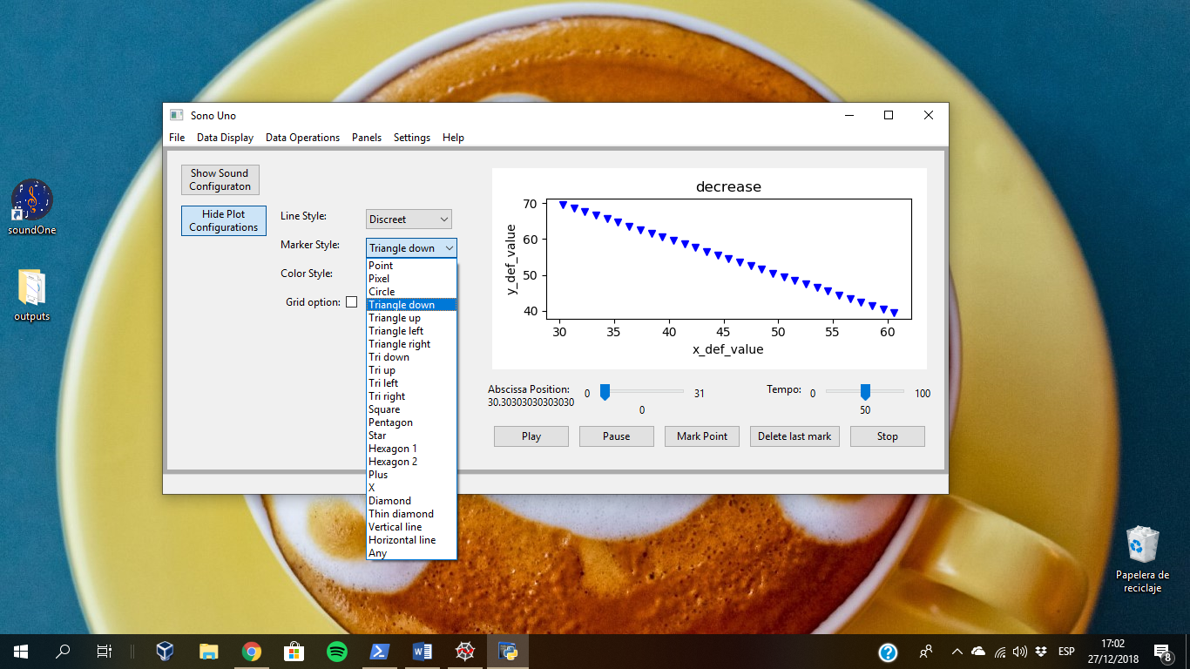

*Image 76 - The marker style element is a drop-down list, where are a lot of options. In the image the triangle down marker style is selected and represent each coordinate of the data.*

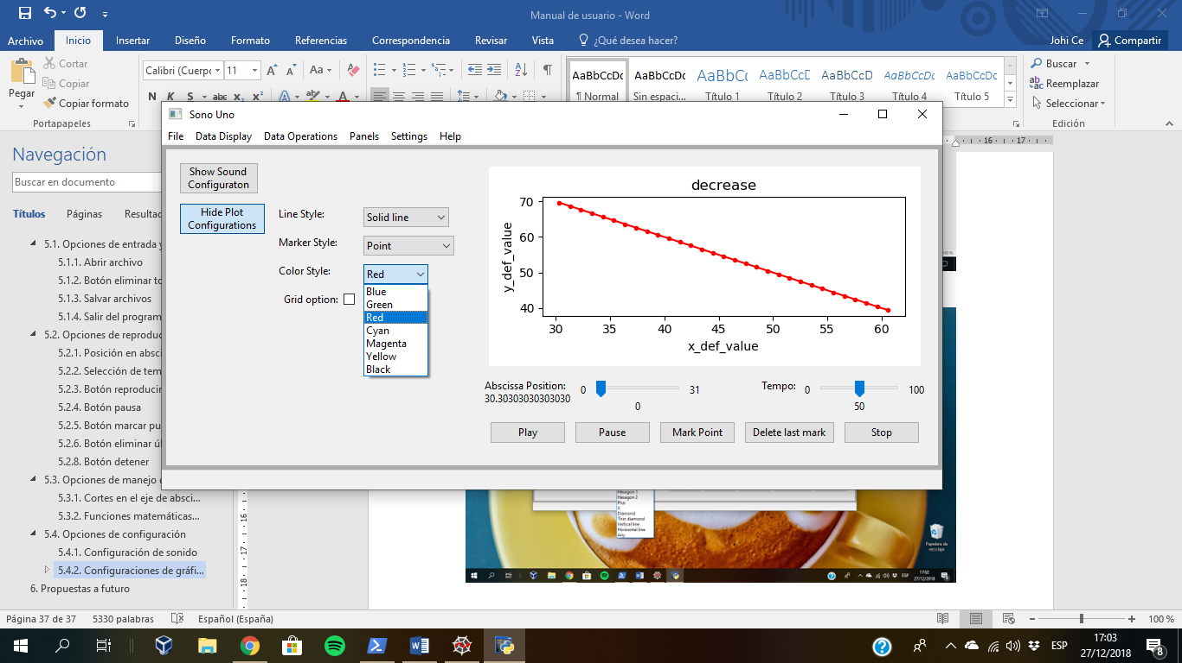

*Image 77 - The color style element is a drop-down list, where are seven options. In the image the red color style is selected. In addition, the solid line style and point marker are chosen.*

#### 4.4.3.2. Grid options

Firstly, to add the grid at the plot, the user has to check the checkbox with the grid option label. Then, the software shows three new elements that allow to configure the grid style (color, line style and width) (Image 78).

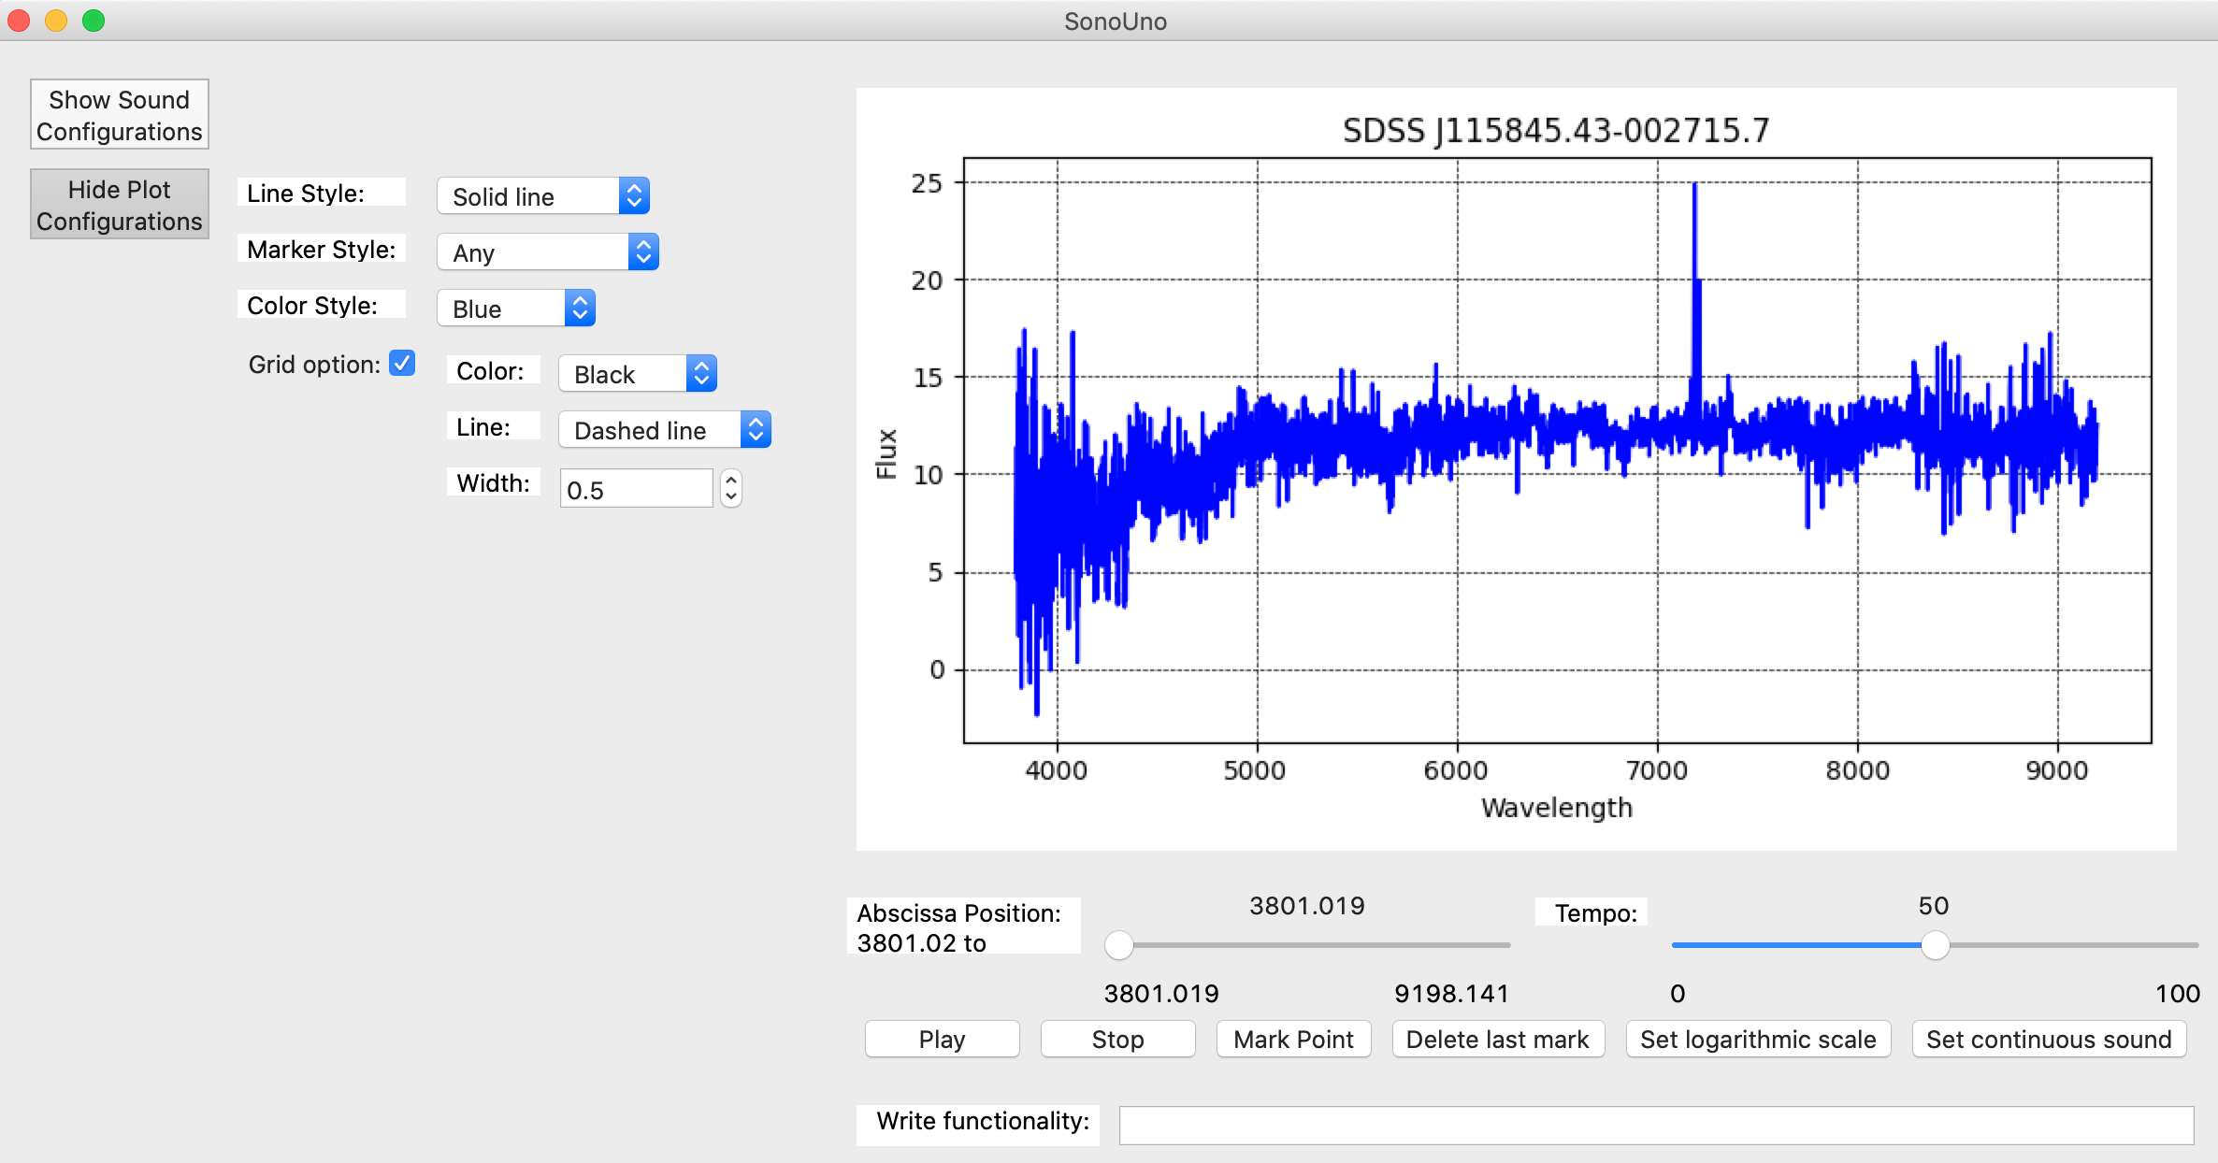

*Image 78 - The grid option is selected, this action shows the grid on the plot and enable three elements for set the grid style (color, line and width).*

To change the color, the drop-down list placed after the color label is used, allow the user to choose between eight colors. In the Image 79 is shown the color list and the grid in the plot with black color.

The line style option, allow the user to choose between four options: Solid, Dashed, Dash-dot and Dotted. The drop-down list is found after the line label, under the color option. In the Image 80 is show the line style list and the continuous style is selected.

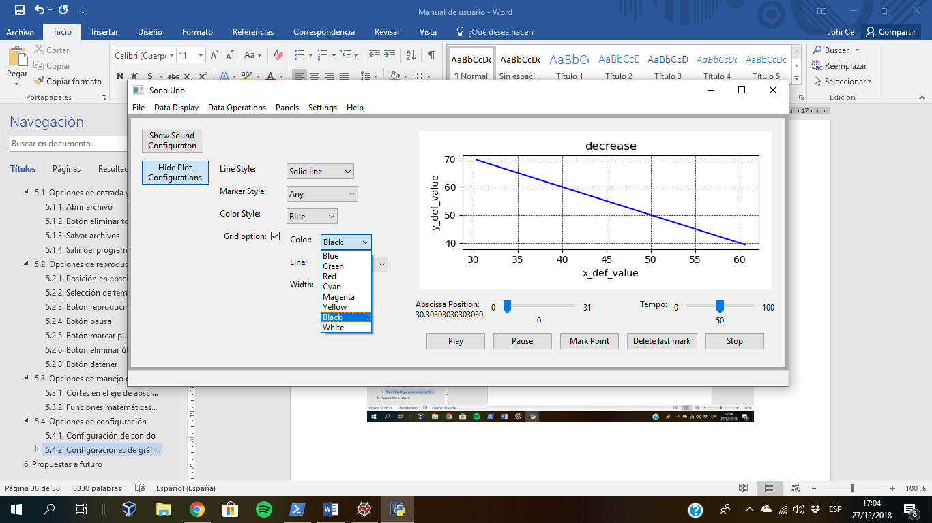

*Image 79 - The grid color style element is a drop-down list, where are eight options. In the image the black color style is selected.*

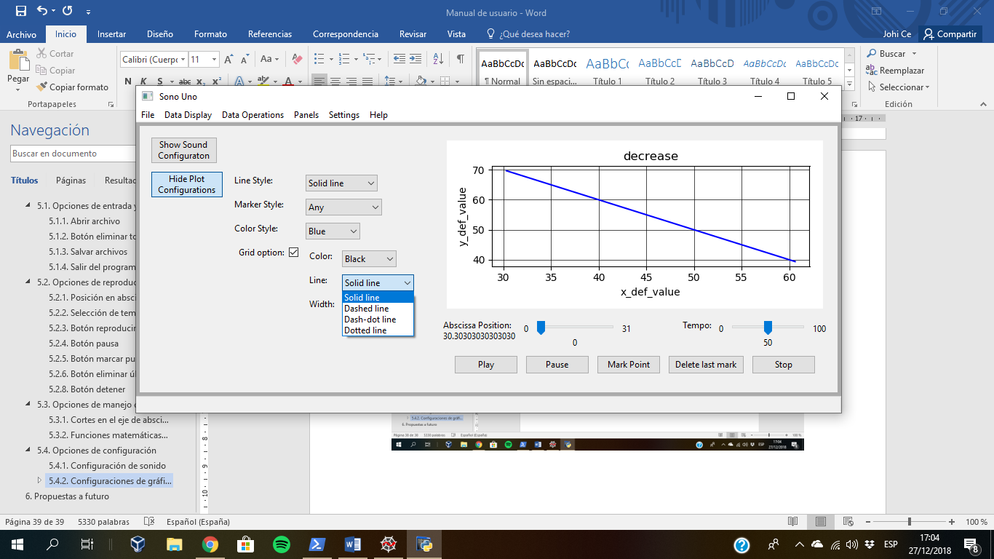

*Image 80 - The grid line style element is a drop-down list, where are four options. In the image the solid line style is selected.*

Finally, to adjust the width of the grid line, there is a number box with the width label, in which the user can type or use the arrow button to increase or decrease the value. In the Image 81 the width is changed to 1.3, the default width is 0.5.

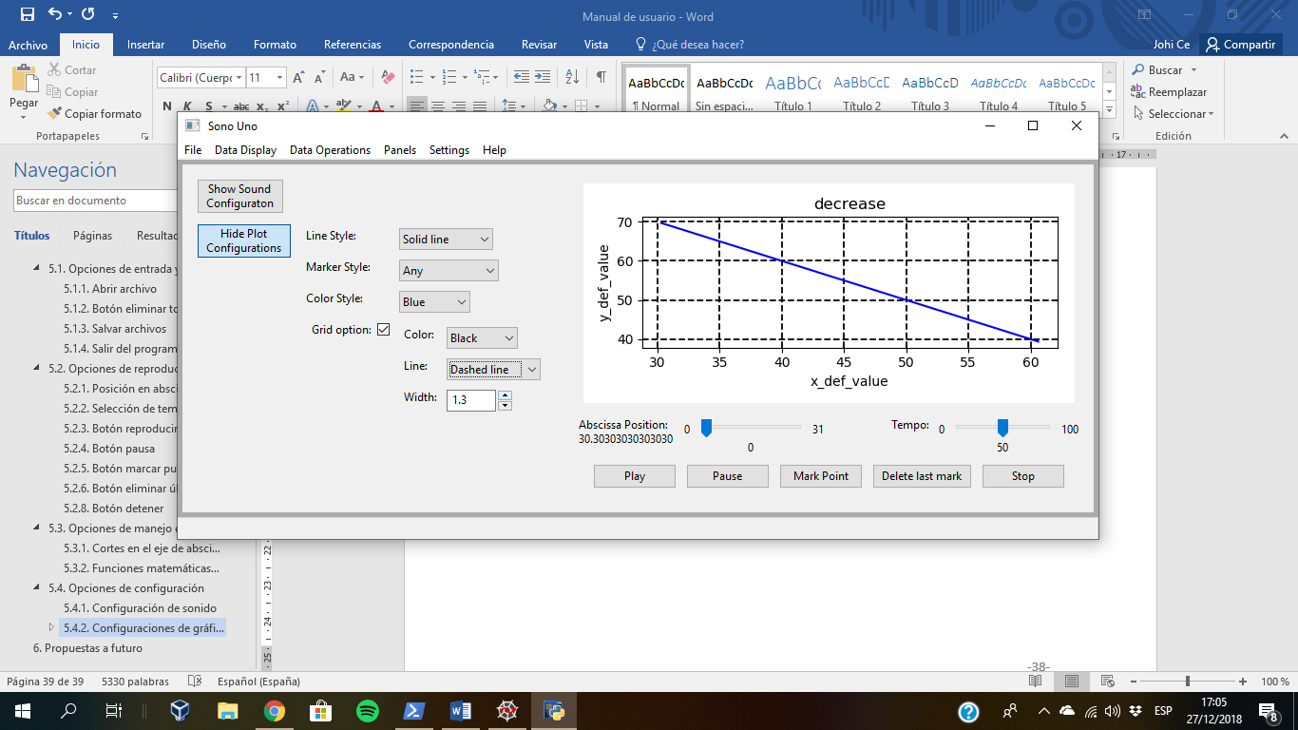

*Image 81 - The grid width style element is a number box with up and down buttons. In the image the number 1.3 is selected.*

## 4.5. Help options

Finally, the software presents a Help section with two items: About and User Manual (Image 82). The item About display a dialog message with some data about the software (Image 83) and the item User manual open the web page with the documentation of the software (<https://www.sonouno.org.ar/>) (Image 84).

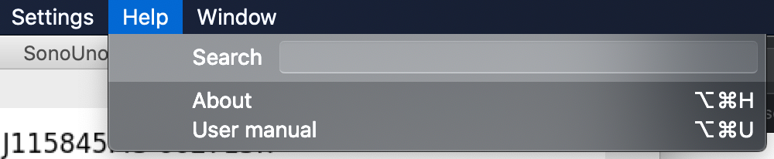

*Image 82 - Shown the submenus of the Help menu.*

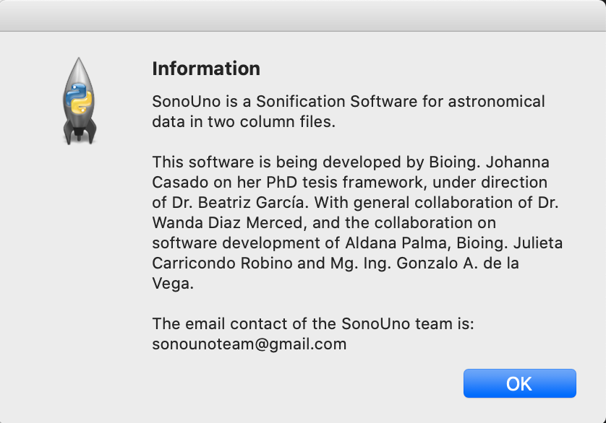

*Image 83 - Shown the dialog message with the sonoUno information, displayed after press the About item on the menu Help.*

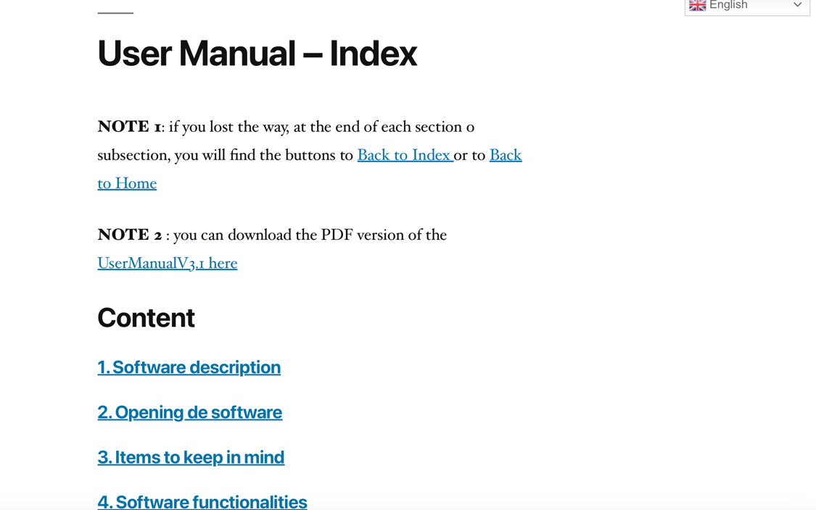

*Image 84 - Shown the web page where the user manual is located (*[*https://www.sonouno.org.ar/usermanual/*](https://www.sonouno.org.ar/usermanual/)*).*